Sprint 1: Business Understanding

1.1 Company Background
The company operates an online retail business where customers purchase products through an e-commerce platform.
The business needs visibility into sales performance, customer behaviour, product demand, order fulfilment, and payment patterns.
Management wants to identify:
- Which products and categories generate the most revenue?
- Which customers contribute the most business value?
- How are sales changing over time?
- Which payment methods are most commonly used?
- How significant are cancelled orders?
- Which customers are repeat purchasers?
- Which products may require inventory attention?
- Which areas provide opportunities for business growth?

1.2 Role
Assume the role of a BI Analyst supporting the E-Commerce Business Intelligence team.
Your responsibility is to:
- Understand the business requirements.
- Explore the available datasets.
- Identify data-quality issues.
- Clean and transform the data.
- Design an appropriate data model.
- Define meaningful business KPIs.
- Create DAX measures and calculated columns where required.
- Build interactive Power BI dashboards.
- Identify business insights.
- Provide actionable recommendations to management.
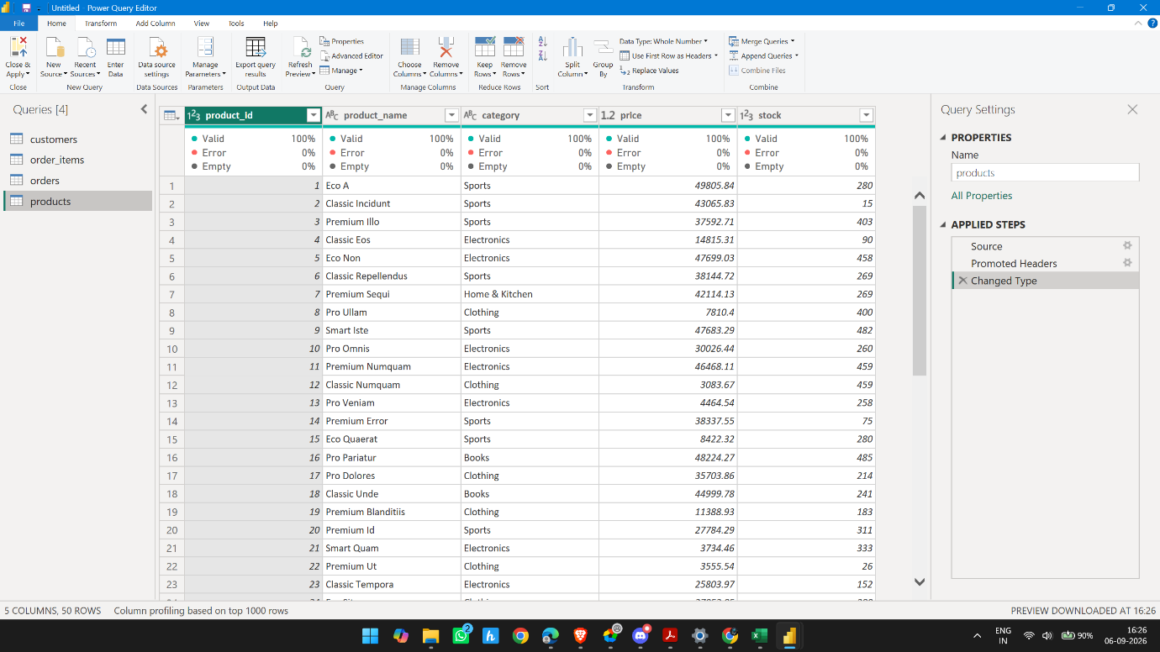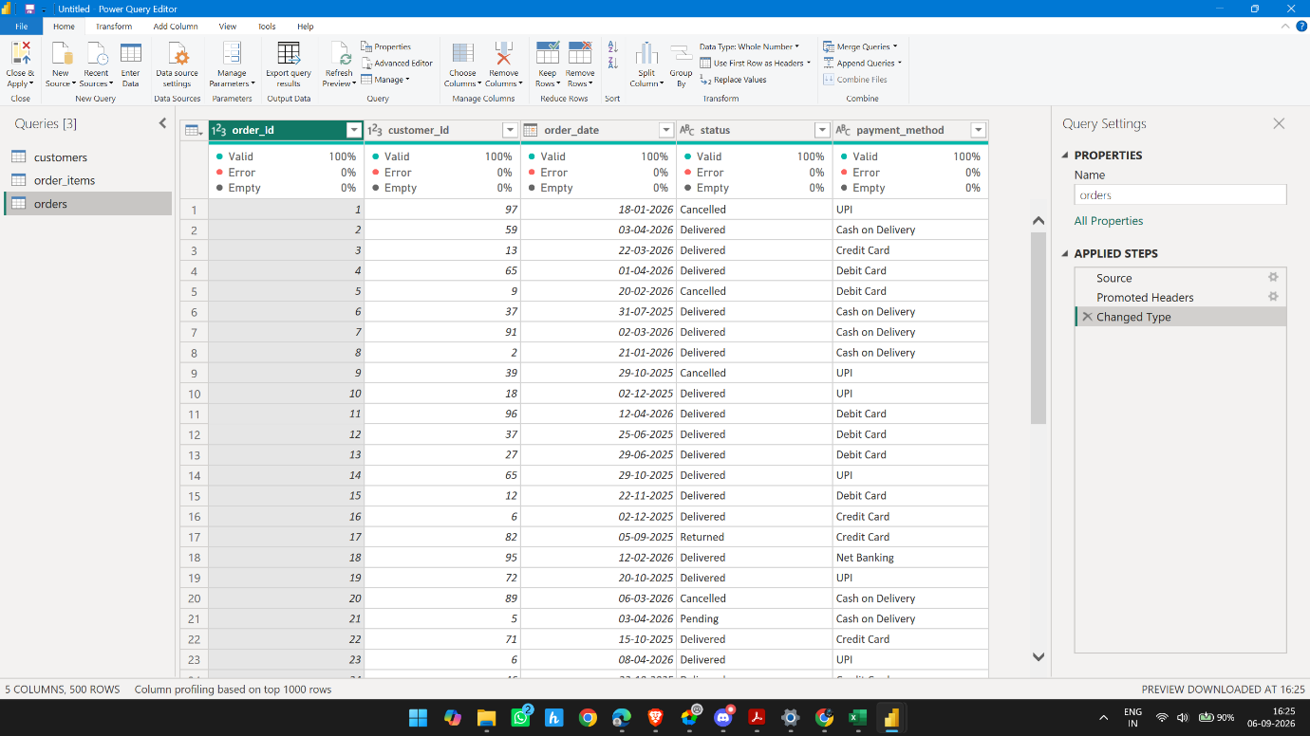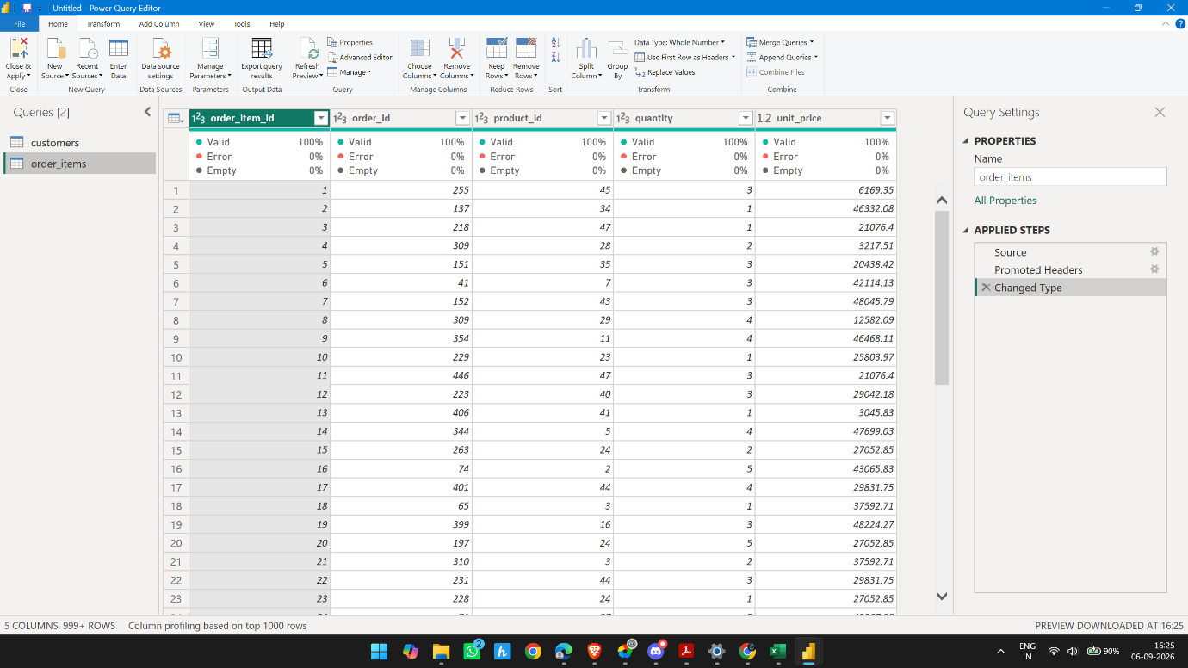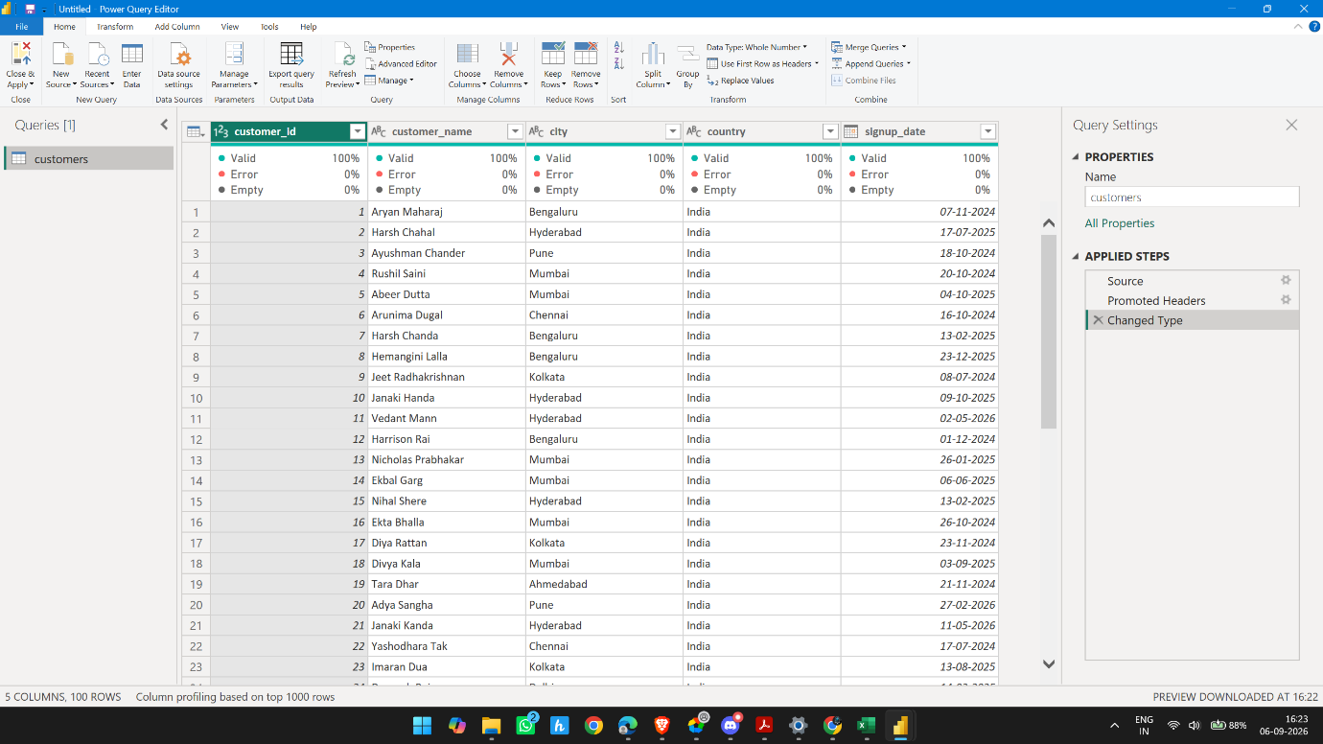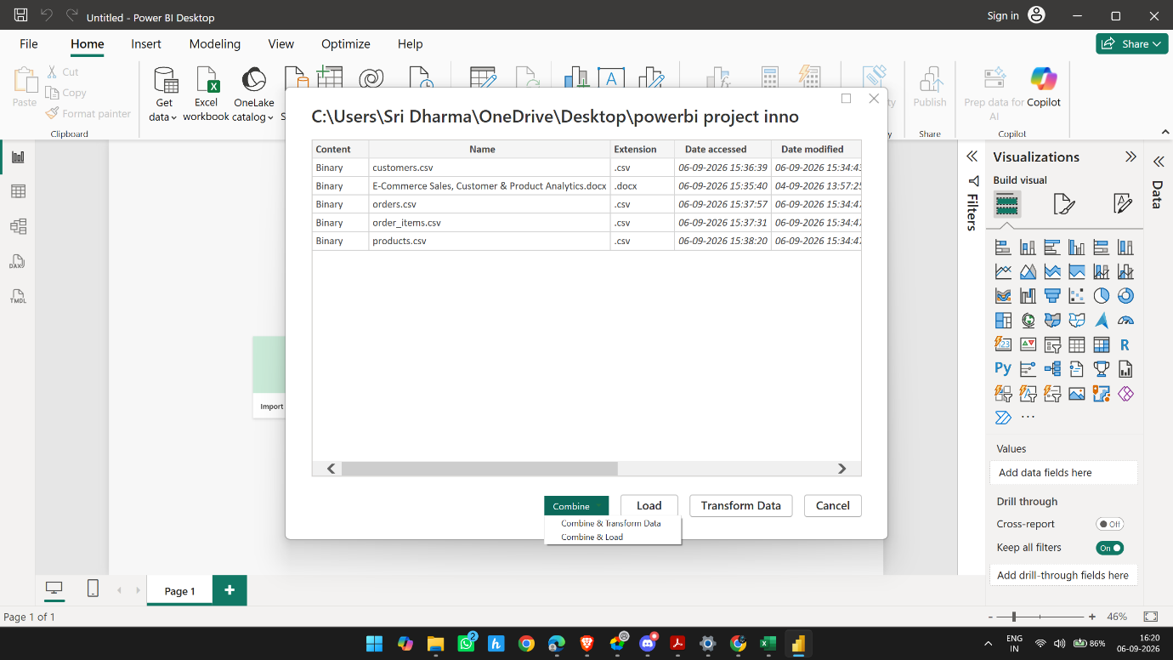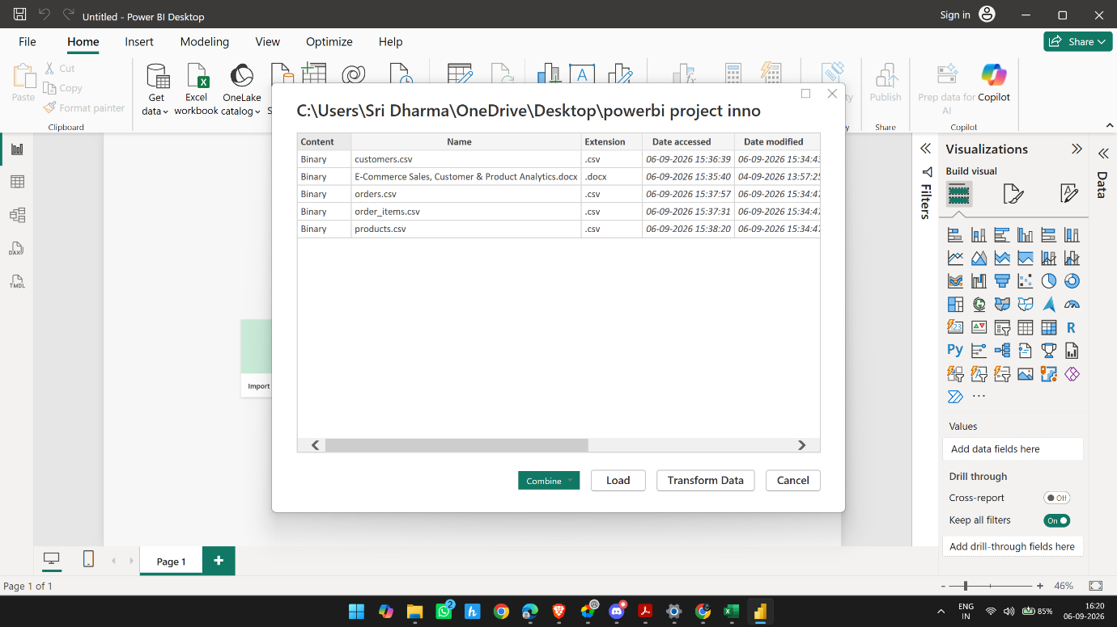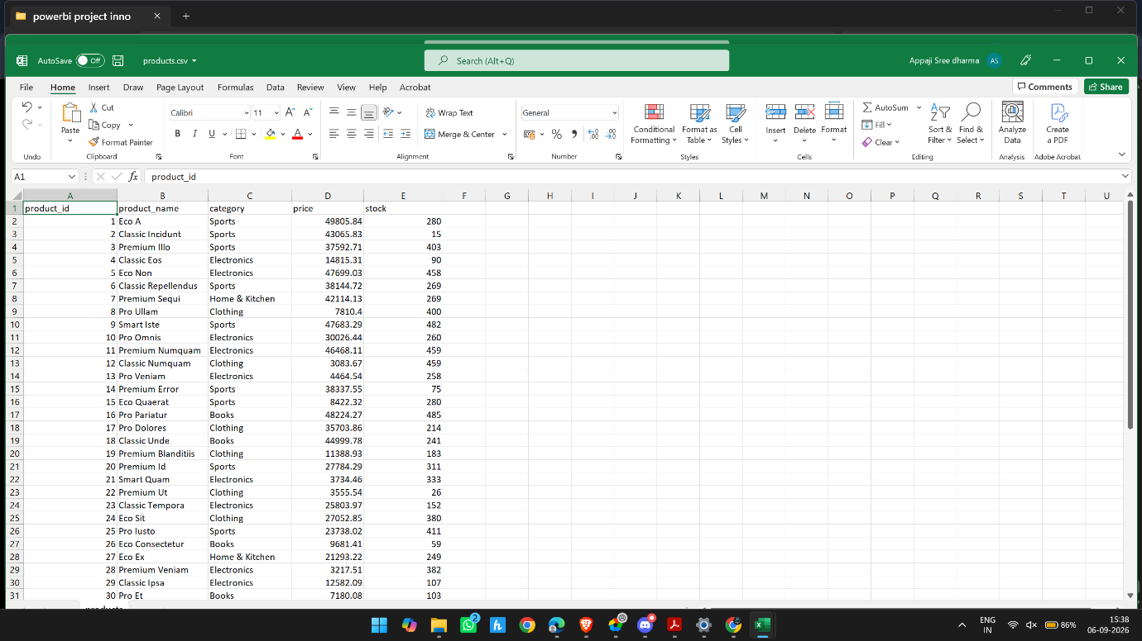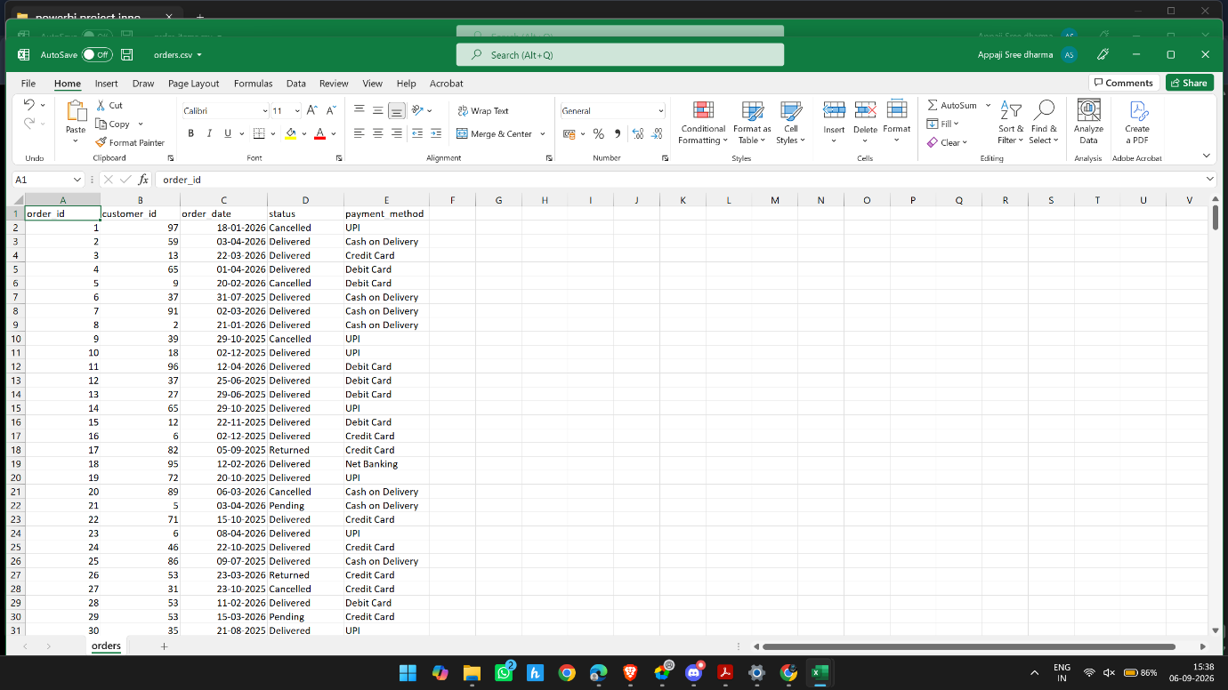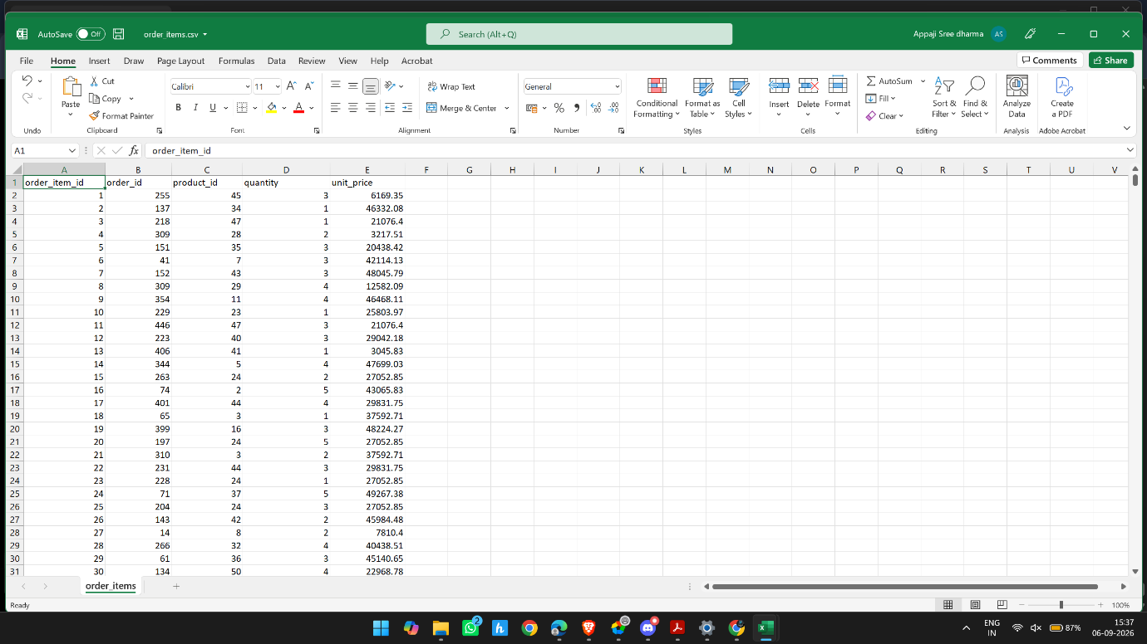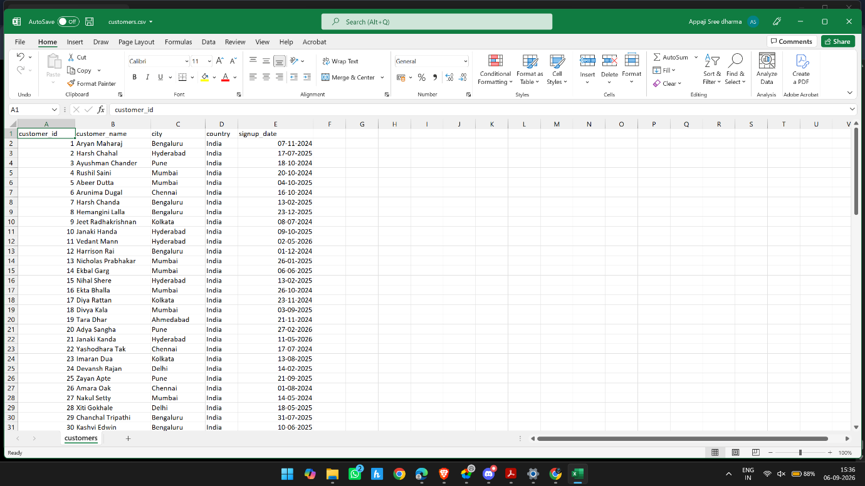

Customers — Sprint 2.2 Data Understanding
The assignment requires us to profile each table for:
- Rows and columns
- Data types
- Unique IDs
- Duplicate records
- Missing values
- Invalid dates
- Invalid numeric values
- Category inconsistencies
- Relationships between IDs
- A short Data Quality Summary

1. Structure
Check | Finding | Status
Rows | 100 | ✅
Columns | 5 | ✅
Column names | customer_id, customer_name, city, country, signup_date | ✅
Data types | ID = Whole Number; name/city/country = Text; signup date = Date | ✅

2. ID / Primary Key
customer_id is the Primary Key.
Check | Finding | Status
Count | 100 | ✅
Distinct | 100 | ✅
Unique | 100 | ✅
Empty | 0 | ✅
Errors | 0 | ✅
Conclusion: Every customer has one unique ID, so customer_id is suitable as the Primary Key.

3. Missing Values
We checked the column quality:
Column | Empty | Error
customer_id | 0% | 0%
customer_name | 0% | 0%
city | 0% | 0%
country | 0% | 0%
signup_date | 0% | 0%
customer_name also showed Empty string = 0.
Conclusion: No missing/empty values found. ✅

4. Duplicates
Duplicate customer_id: None — 100 unique IDs for 100 rows. ✅
Duplicate full records: ⚠️ We have NOT formally checked this yet.
So we should not say this is completed. This is the one remaining customer-table check.

5. Data Validity

signup_date
Check | Result
Count | 100
Error | 0
Empty | 0
Distinct | 94
Unique | 88
Minimum | 14-May-2024
Maximum | 11-May-2026
Repeated signup dates are completely acceptable because multiple customers can register on the same day.
Conclusion: No apparent invalid-date issue. ✅

Numeric validity
There is no business numeric measure such as price, quantity, or stock in this table.
customer_id being numeric is an identifier, so negative/zero-value analysis isn't a business-validity check in the same way it is for price, quantity, or stock.
Conclusion: Not applicable.

6. Consistency

country
We found 1 distinct value: India.
No apparent country inconsistency. ✅

city
We found 8 distinct cities:
- Ahmedabad
- Bengaluru
- Chennai
- Delhi
- Hyderabad
- Kolkata
- Mumbai
- Pune
No null/blank city values were observed and no obvious case/spacing variants were identified. ✅

customer_name
- 100 distinct
- 100 unique
- 0 empty strings
- 0 errors
No obvious name-format problem was identified from our inspection. ✅

Category / Status / Payment Method
Not applicable to customers; those columns belong to other tables.

7. Relationships
This is a cross-table check, so we haven't completed it yet.
We eventually need to verify:
customers.customer_id
↑
│
orders.customer_id
Specifically:
Does every customer_id in orders exist in customers?
We'll perform that when we profile/model the tables together.

Final Customers Data Understanding Summary
Requirement from assignment | Customers | Status
Rows/columns | 100 × 5 | ✅
Column names | Identified | ✅
Data types | Appropriate | ✅
Unique ID | customer_id | ✅
Duplicate IDs | None | ✅
Missing values | None | ✅
Invalid dates | No apparent issue | ✅
Invalid numeric values | N/A | —
City consistency | 8 values, no obvious issue | ✅
Country consistency | India | ✅
Name consistency | No obvious issue | ✅
Full duplicate records | Not formally checked | ⚠️
Relationship with Orders | Later cross-table check | ⏳

So our correct analyst conclusion is:
Customers table profiling is substantially complete. No obvious data-quality issues have been identified so far. We still need to formally verify full-row duplicates and later validate the customer-to-order relationship.

✅ Products Data Understanding — Completed checks
We now have:
Products
│
├── Structure ✅
├── Product ID / Primary Key ✅
├── Missing values ✅
├── Duplicate IDs ✅
├── Price validity ✅
├── Stock validity ✅
├── Category consistency ✅
└── Product name consistency ✅

What we've found
- 50 rows, 5 columns
- product_id → 50/50 unique → valid PK
- No missing/error values
- 5 categories
- No category blanks
- Prices: ₹2,718.30–₹49,805.84
- No zero/NaN prices
- Stock: 15–500
- No zero or negative stock
- Product names have no obvious formatting problems
There is still the formal full-row duplicate check, just as with Customers. We can handle that later as a final duplicate-record check rather than modifying the table now.
Yes. Data Understanding is essentially completed. ✅
But I want to make one distinction: we have profiled the data and identified the quality status. We have not yet performed formal duplicate-row and referential-integrity tests. Those belong to the next data-quality/cleaning step. So we should not claim we proved those yet.

1. What we learned about the datasets
Table | Rows | Columns | Purpose
Customers | 100 | 5 | Customer profile & registration
Products | 50 | 5 | Product, category, price & stock
Orders | 500 | 5 | Order-level information
Order Items | 1,500 | 5 | Products/quantities within orders

Customers
Columns:
customer_id, customer_name, city, country, signup_date
Findings:
- customer_id → 100 distinct, 100 unique → good candidate primary key ✅
- No errors or empty values observed ✅
- 8 cities
- Country = India
- Signup dates range from 14-May-2024 to 11-May-2026
- Repeated signup dates are normal
- No obvious formatting/category inconsistency observed
Conclusion:
Customers data appears clean based on profiling. No immediate column-level cleaning issue identified.

Products
Columns:
product_id, product_name, category, price, stock
Findings:
- product_id → 50 distinct, 50 unique → primary key looks valid ✅
- 5 categories:
  - Books
  - Clothing
  - Electronics
  - Home & Kitchen
  - Sports
- Price:
  - Minimum ≈ ₹2,718.30
  - Maximum ≈ ₹49,805.84
  - No blanks/errors/zero values
- Stock:
  - Minimum = 15
  - Maximum = 500
  - No blanks/errors/zero/negative values observed
Conclusion:
Products data appears clean based on profiling. No immediate price or stock-quality issue identified.

Orders
Columns:
order_id, customer_id, order_date, status, payment_method
Findings:
- order_id → 500 distinct, 500 unique → primary key looks valid ✅
- customer_id → 99 distinct customers placed orders
- Customer IDs range from 1–100
- Order dates range from 12-May-2025 to 12-May-2026
- 4 observed statuses:
  - Delivered
  - Cancelled
  - Pending
  - Returned
- 5 observed payment methods:
  - Cash on Delivery
  - Credit Card
  - Debit Card
  - Net Banking
  - UPI
- No errors/empty values observed
Conclusion:
Orders data appears clean at the column level, with no obvious missing or malformed values.

Order Items
Columns:
order_item_id, order_id, product_id, quantity, unit_price
Now we correctly changed profiling to Entire Dataset, so these results cover all 1,500 rows.
Findings:
- order_item_id → 1,500 distinct, 1,500 unique ✅
- order_id → 474 distinct; repetition is expected because one order can contain multiple items
- product_id → 50 distinct; repetition is expected because products can appear in many orders
- quantity:
  - Min = 1
  - Max = 5
  - No zero
  - No empty/error values
- unit_price:
  - Min ≈ ₹2,718.30
  - Max ≈ ₹49,805.84
  - No zero
  - No empty/error values
Conclusion:
Order Items data appears clean based on full-dataset profiling. No obvious quantity or unit-price issue identified.

2. Overall Data Quality conclusion
This is the important part for your assignment.

We found:
Quality check | Current conclusion
Data types | ✅ Appropriate
Missing/empty values | ✅ None observed
Column errors | ✅ None observed
Primary-key uniqueness | ✅ Looks good
Quantity = 0 | ✅ None
Negative quantity | ✅ None indicated
Zero/invalid prices | ✅ None
Negative stock | ✅ None
Category values | ✅ Consistent observed categories
Status values | ✅ 4 observed values
Payment methods | ✅ 5 observed values
Full duplicate rows | ⚠️ Formal check still to do
Cross-table invalid IDs | ⚠️ Formal validation still to do

Therefore:
We should NOT artificially clean the data.
Our current professional conclusion is:
The initial profiling indicates that the datasets are structurally consistent and contain no obvious missing, error, zero-price, invalid-quantity, or negative-stock issues. Primary-key columns also appear unique. Formal duplicate-record and referential-integrity checks will be performed before finalizing the cleaning stage.

3. What Data Understanding means
You've now actually completed the important understanding part:
We know:
What data do we have?
↓
How much data?
↓
What does each table represent?
↓
What are the columns?
↓
What are their data types?
↓
What are the ID columns?
↓
Are values missing/error?
↓
What values/categories exist?
↓
Are numeric values sensible?
↓
What relationships should exist?
That's exactly the mindset you need to explain in an interview.

One correction to our terminology
Don't say:
"Data Understanding is 100% finished and there are no duplicates."
Instead say:
"Data understanding and initial profiling are complete. The profiling did not reveal obvious data-quality issues. I then perform formal duplicate and referential-integrity checks as part of the data-cleaning validation before making any transformations."

Our cleaning status so far
Cleaning check | Result | Action
Data types | Correct | No change needed
Missing values | None found | No change
Errors | None found | No change
Duplicate records | None found | No change
Invalid quantities | None found | No change
Invalid prices | None found | No change
Negative/zero stock | None found | No change
Customer IDs | Consistent | No change
Order IDs | Consistent | No change
Product IDs | Consistent | No change
Categories | Consistent | No change
Status/payment values | Consistent observed values | No change

2.3 requirement | What we've done | Status
Customers — Missing customer IDs | customer_id: 100/100, no empty/errors | ✅
Duplicate customers | Exact duplicate-row check → 0 | ✅
Blank customer names | No empty values observed | ✅
Inconsistent city names | 8 cities, no obvious inconsistencies | ✅*
Leading/trailing spaces | Not formally checked yet | ⏳
Invalid signup dates | Date type valid, range sensible | ✅
Inconsistent country values | Only India observed | ✅
Products — Duplicate product IDs | product_id: 50 distinct/50 unique | ✅
Missing product names | No empty values | ✅
Category inconsistencies | 5 consistent categories observed | ✅*
Invalid prices | Positive, no zero/errors | ✅
Missing stock values | None | ✅
Negative/zero stock | Min 15 | ✅
Orders — Duplicate order IDs | 500 distinct/500 unique | ✅
Missing customer IDs | No empty values | ✅
Invalid order dates | Valid Date type, sensible range | ✅
Inconsistent status | 4 observed values | ✅*
Inconsistent payment methods | 5 observed values | ✅*
Orders → Customers | IDs 1–100, consistent with Customers | ✅*
Order Items — Duplicate item IDs | 1,500 distinct/1,500 unique | ✅
Invalid order IDs | IDs 1–500, consistent with Orders | ✅*
Invalid product IDs | IDs 1–50, consistent with Products | ✅*
Quantity errors | 1–5, no zero/errors | ✅
Unit-price errors | Positive, no zero/errors | ✅
Missing values | None observed | ✅

2.3: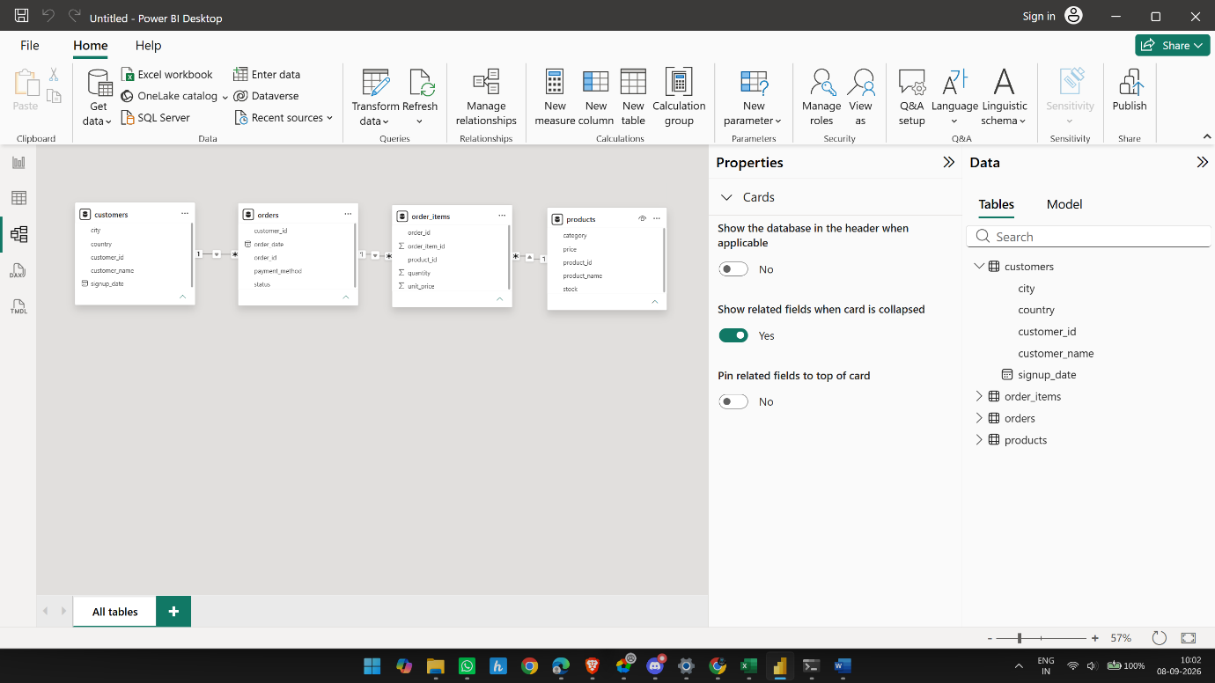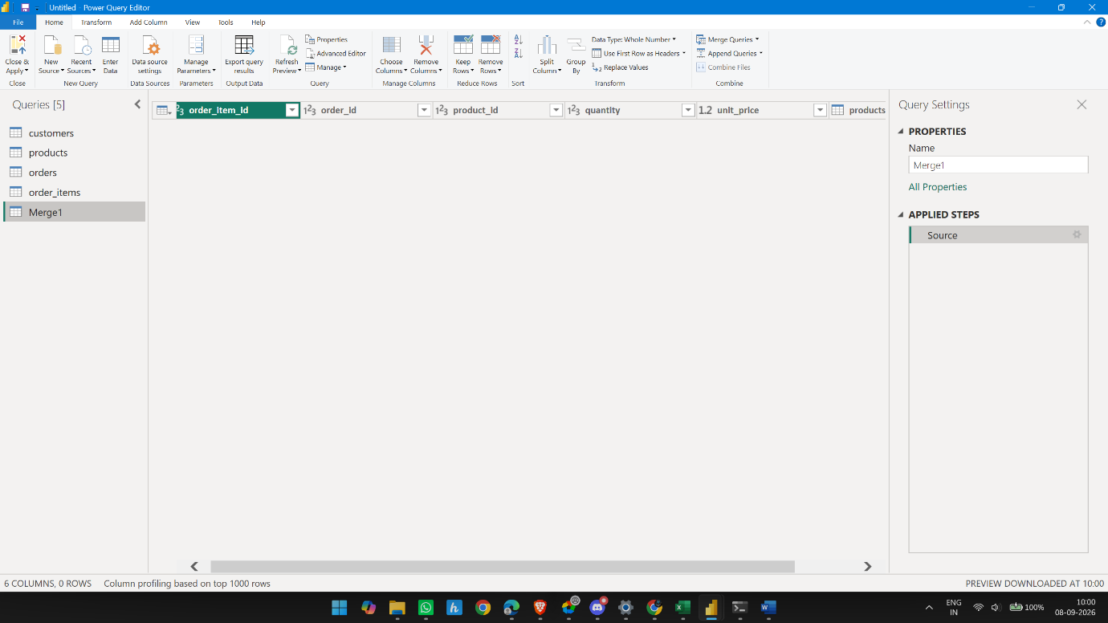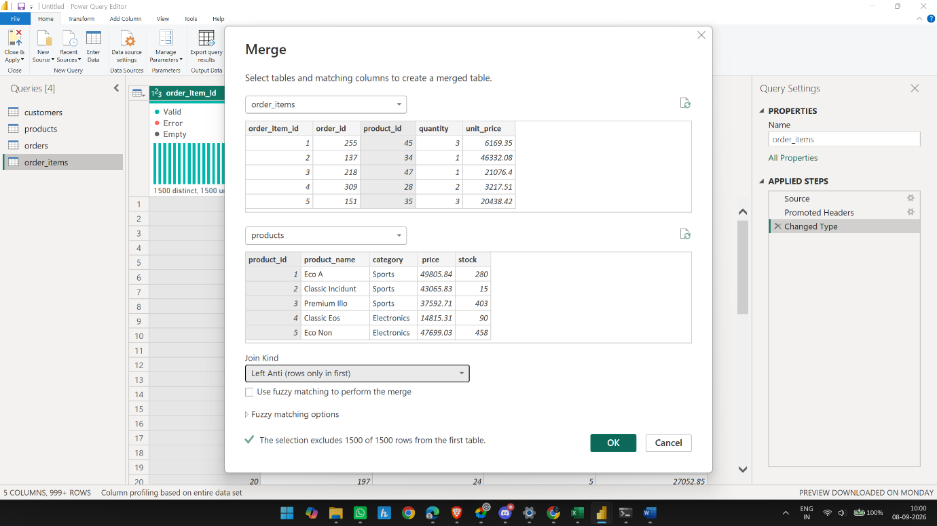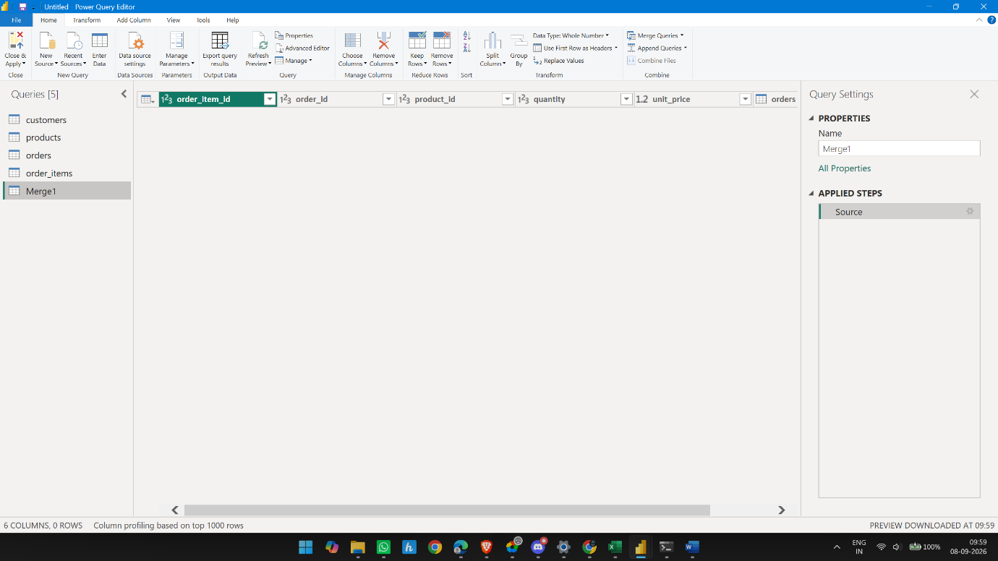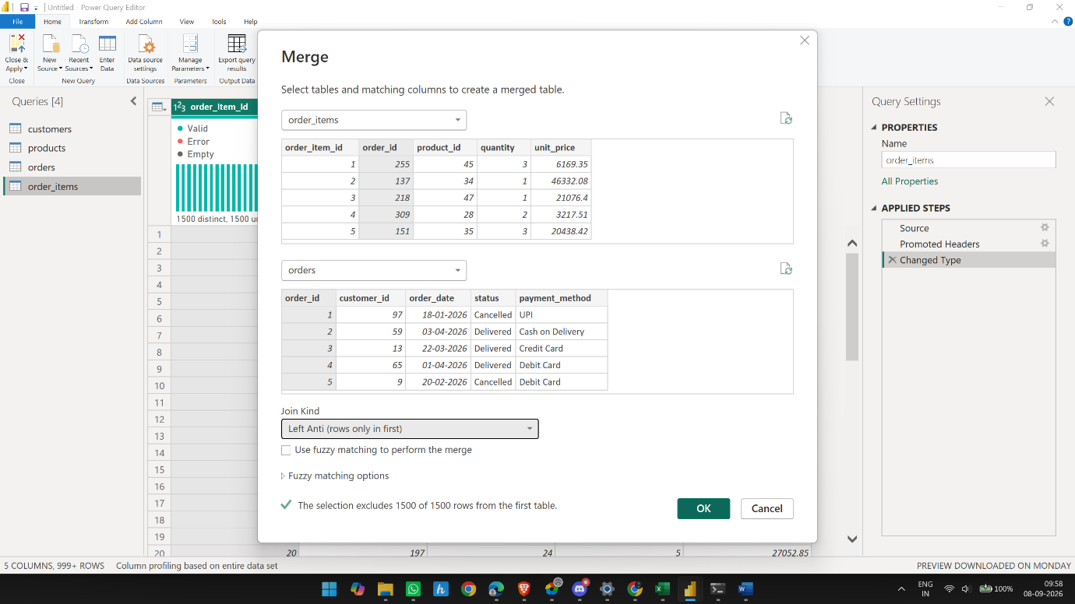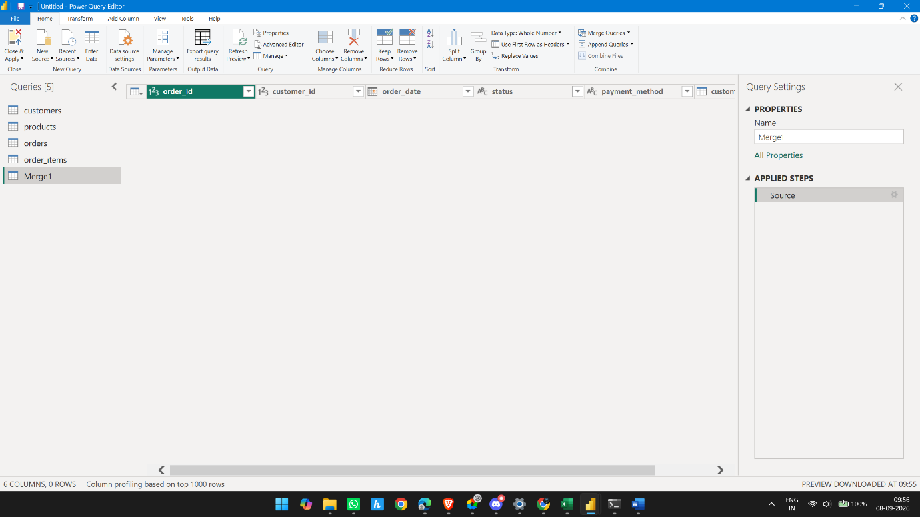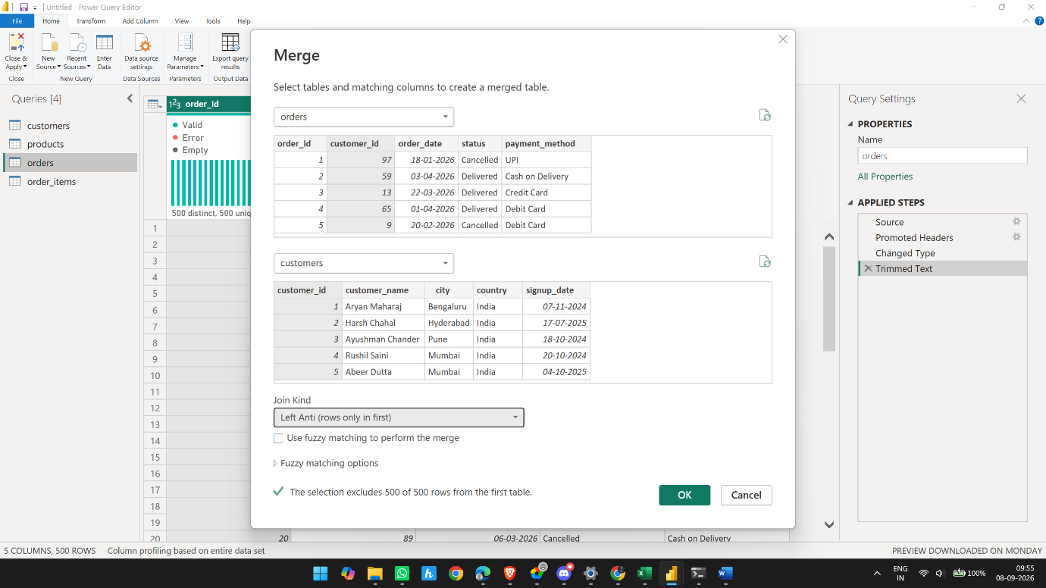
2.3 Data Cleaning is now complete
We have checked everything in the assignment:
- Customers → IDs, duplicates, blanks, cities, spaces, dates, country ✅
- Products → IDs, names, categories, prices, stock ✅
- Orders → IDs, customers, dates, status, payment methods ✅
- Order Items → item IDs, order IDs, product IDs, quantity, unit price, missing values ✅
- Referential integrity → all 3 relationships validated with Left Anti = 0 rows ✅
- 2.4 Create Business Columns
- Where appropriate, create useful analytical columns such as:

Order Value
Order Value = Quantity × Unit Price
- This should generally be created at the Order Item level.
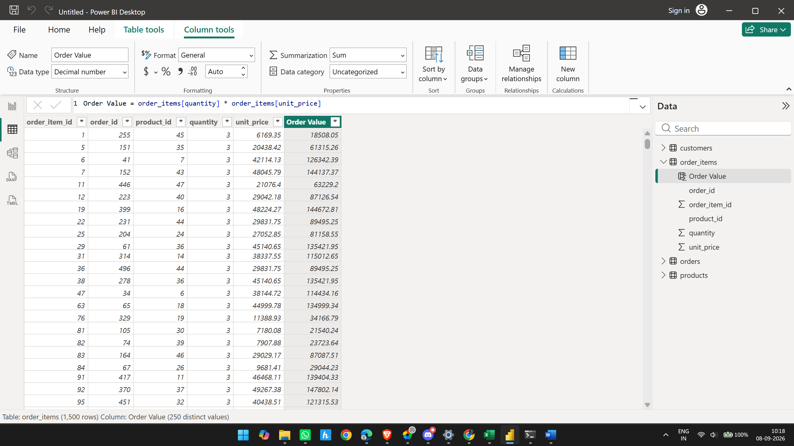

Customer Tenure
Customer Tenure = Analysis Date − Signup Date
- Calculate the number of months or years between customer signup date and the selected analysis date.
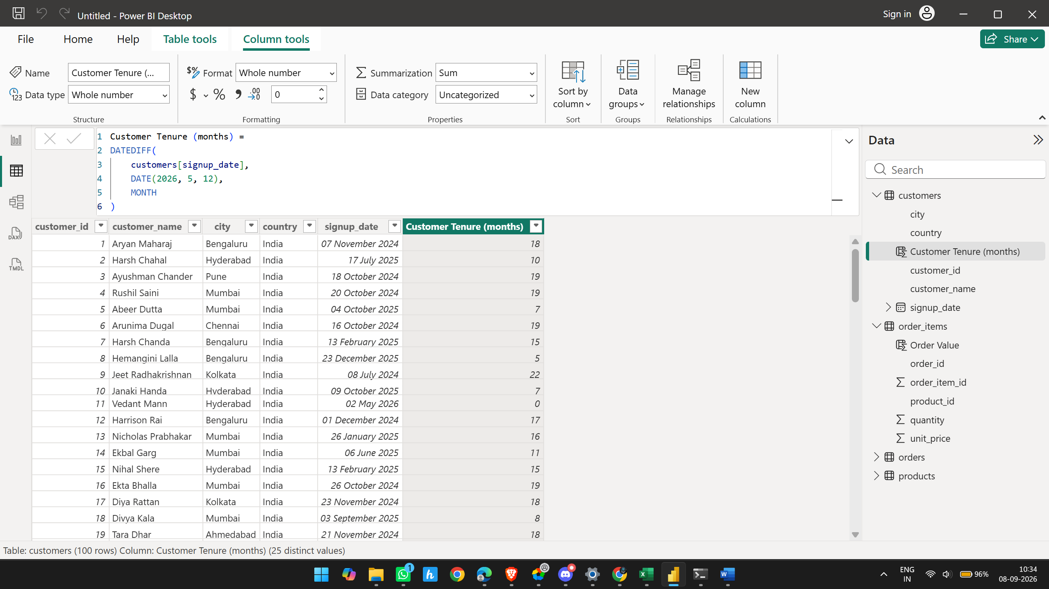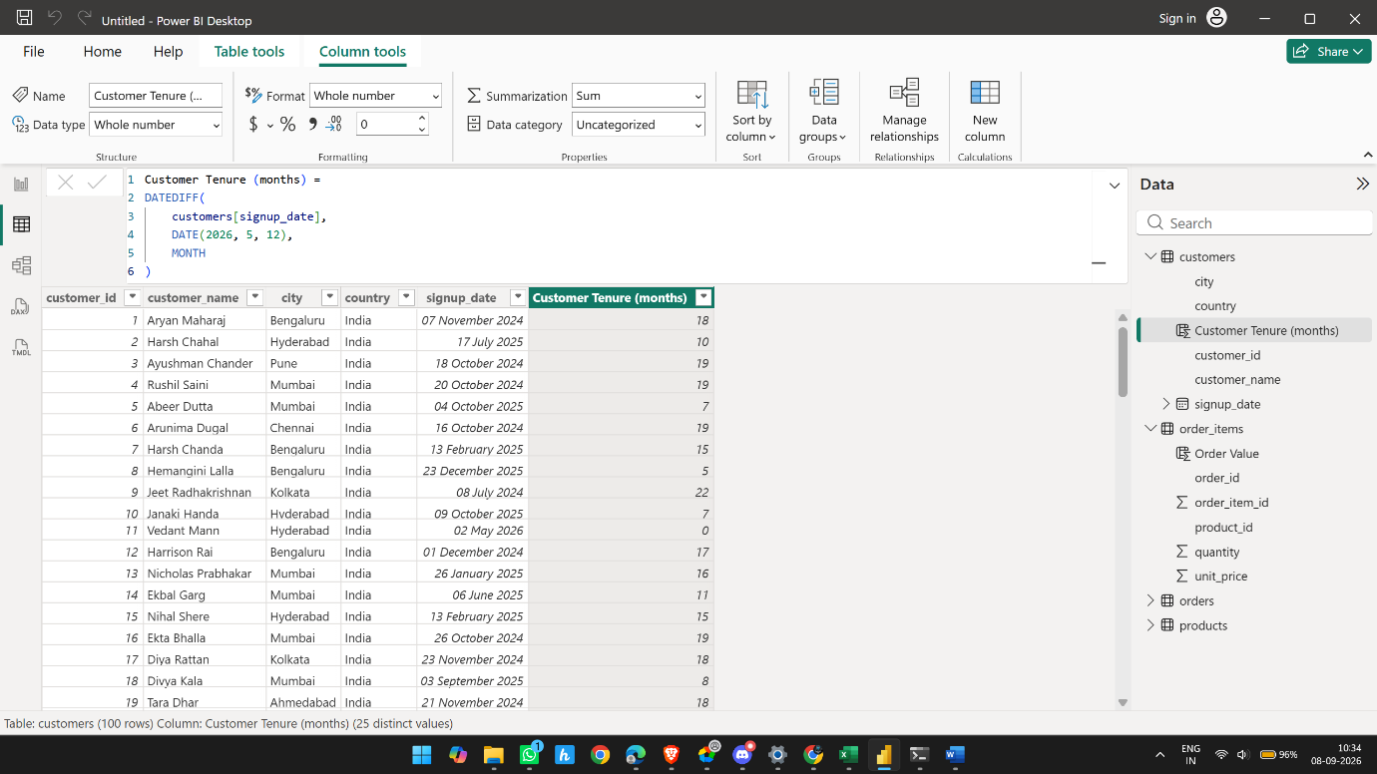

Product Stock Status
Create meaningful categories such as:
Out of Stock
Low Stock
Medium Stock
Healthy Stock
- The thresholds should be decided and documented by the analyst.
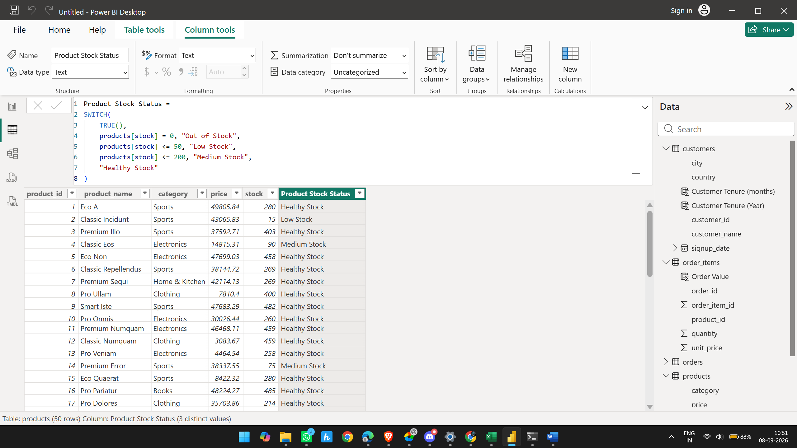

Customer Type
Classify customers based on purchasing behaviour, for example:
One-Time Customer
Repeat Customer
High-Value Customer
- The exact business rules should be defined by the analyst.
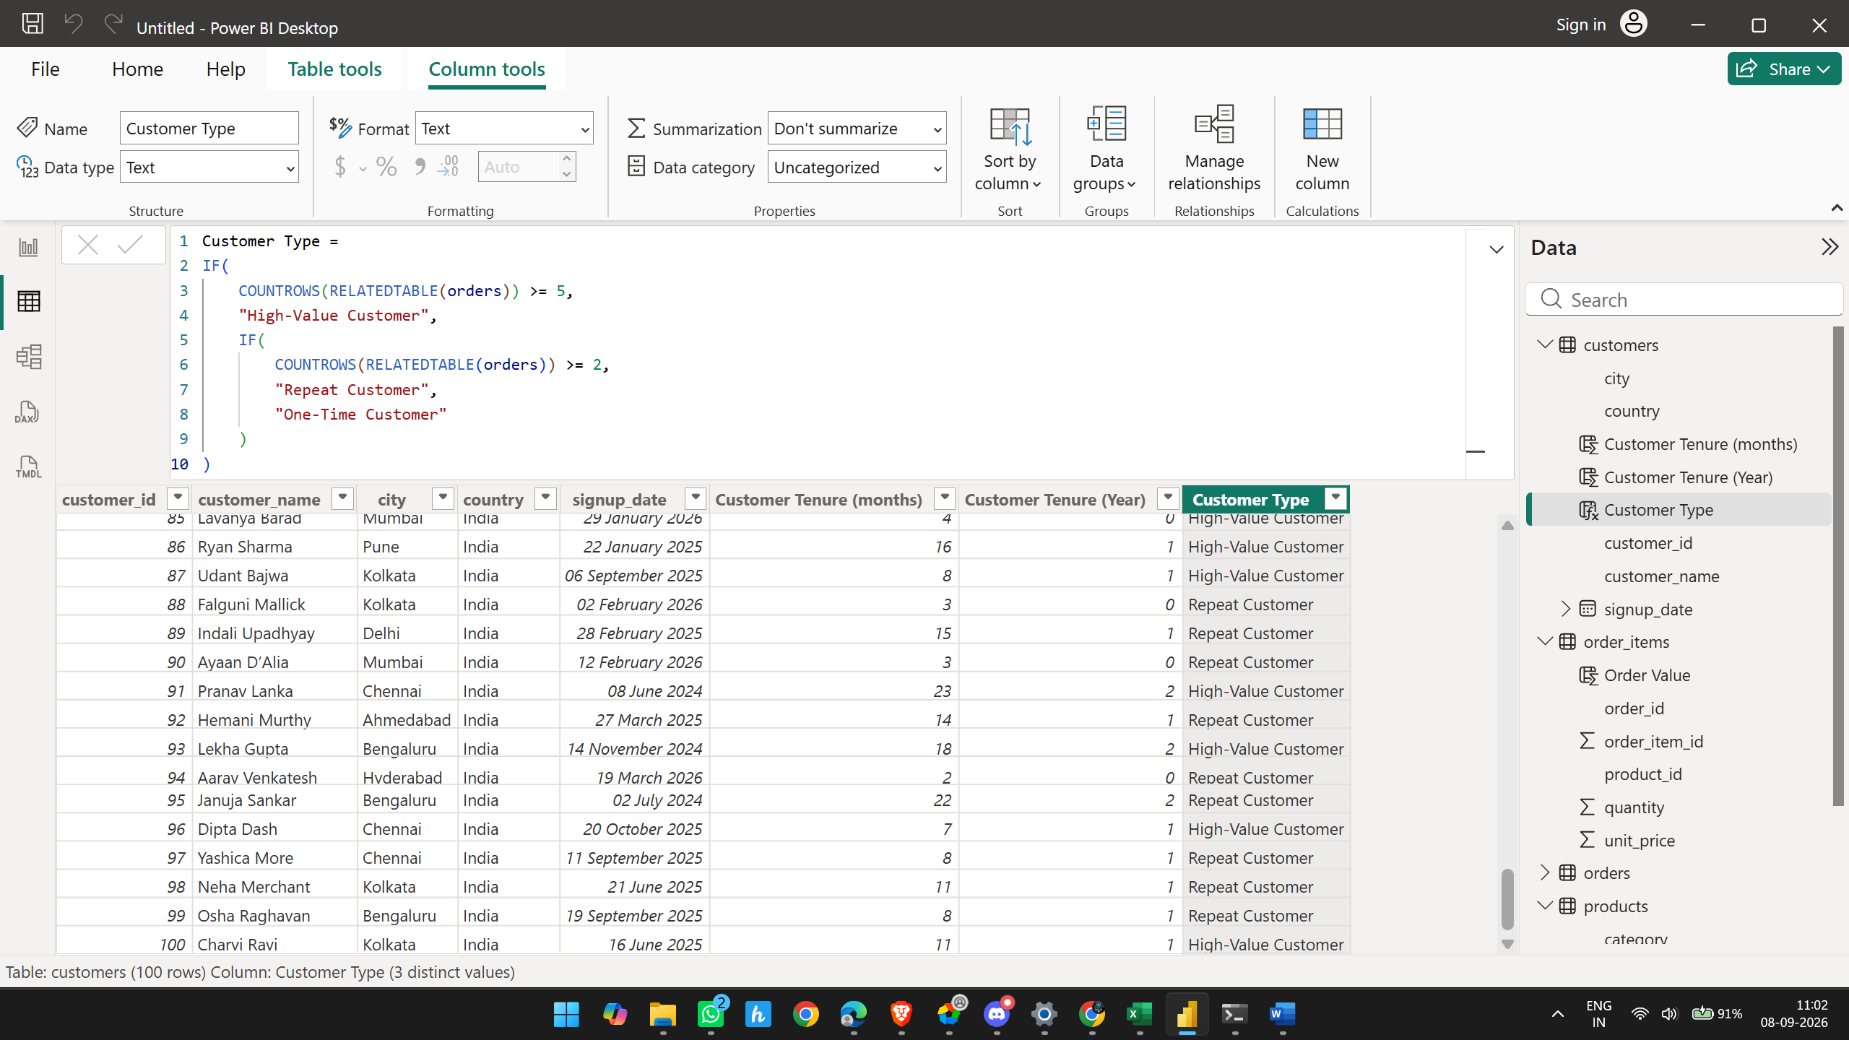

2.5 Build the Data Model
Switch to Model View and create the relationships yourself.
A recommended starting structure is:
Customers → Orders → Order Items ← Products

Create a separate Date table and connect it to the appropriate date field.
Validate each relationship using simple visuals.
If totals are duplicated or unexpectedly inflated, revisit the data model before changing the DAX.

Why do we need a Date table?
Instead of using orders[order_date] directly for every time analysis, we create a proper calendar table.
It will allow us to analyze:
- Year
- Month
- Month Name
- Quarter
- Monthly revenue
- Revenue growth
- Order trends
This will become very important when we start Sprint 3. 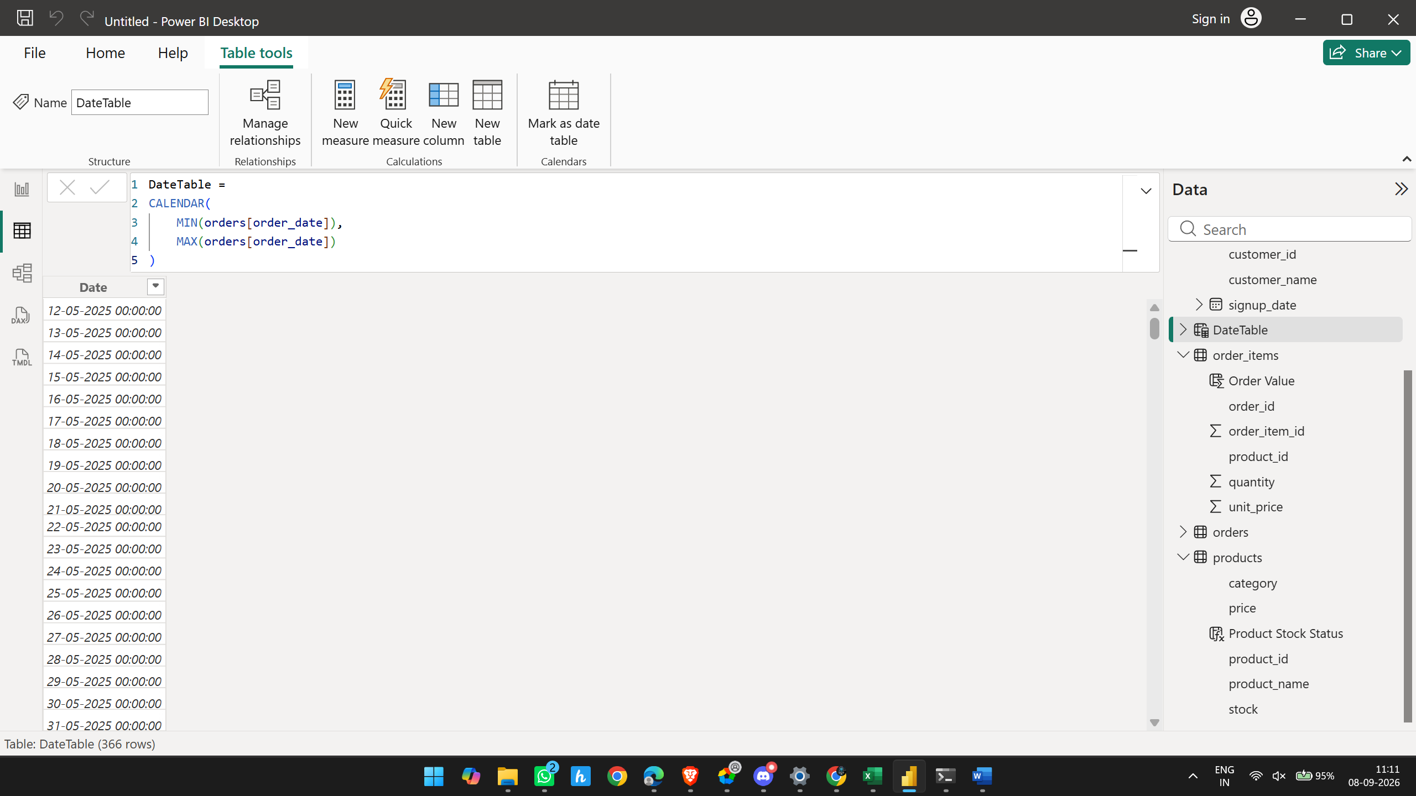
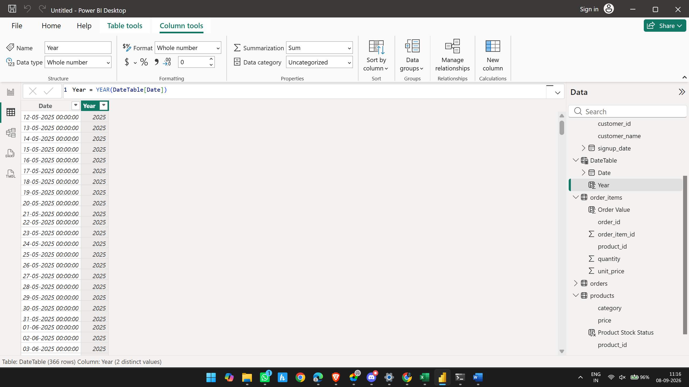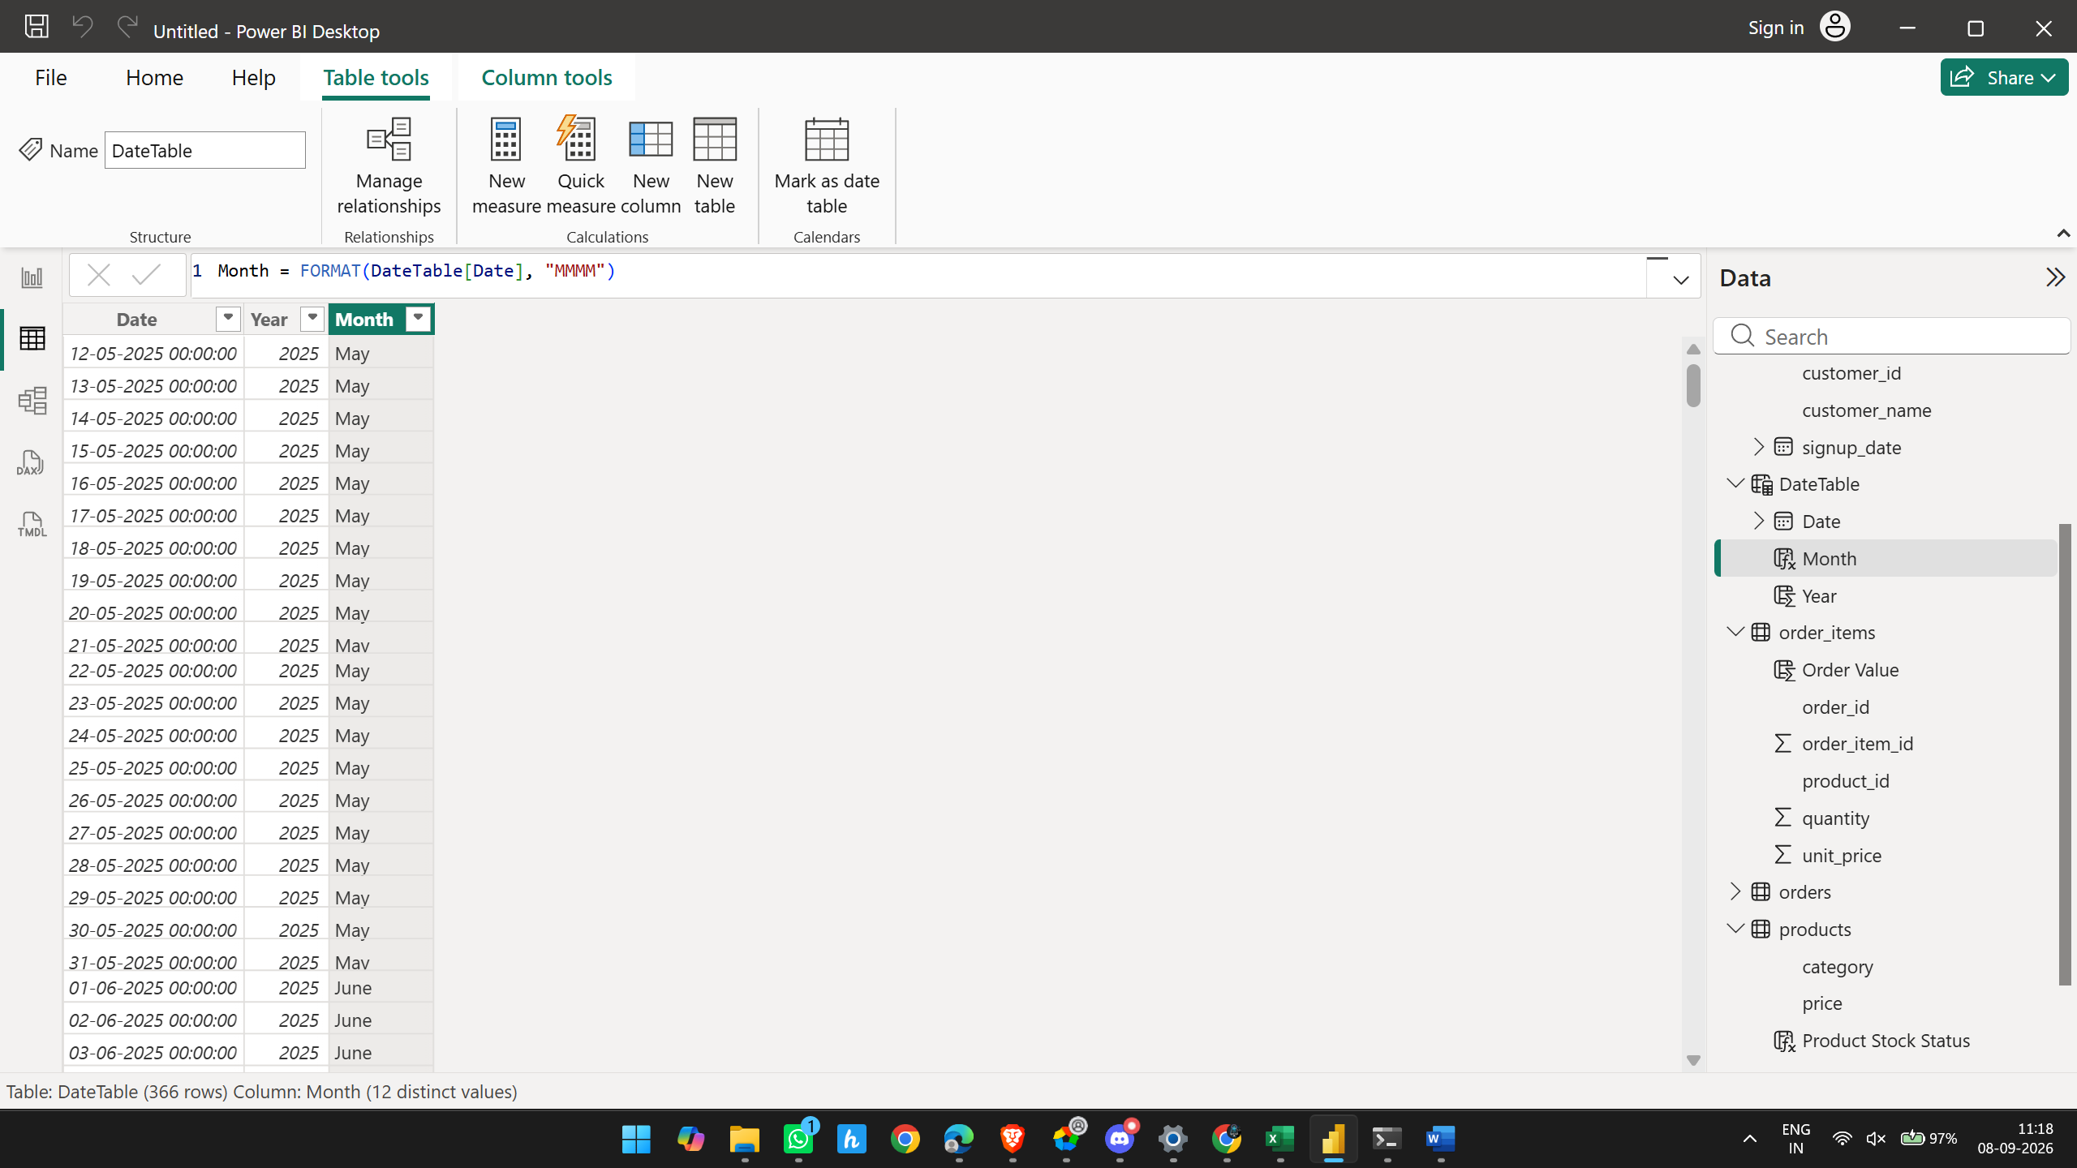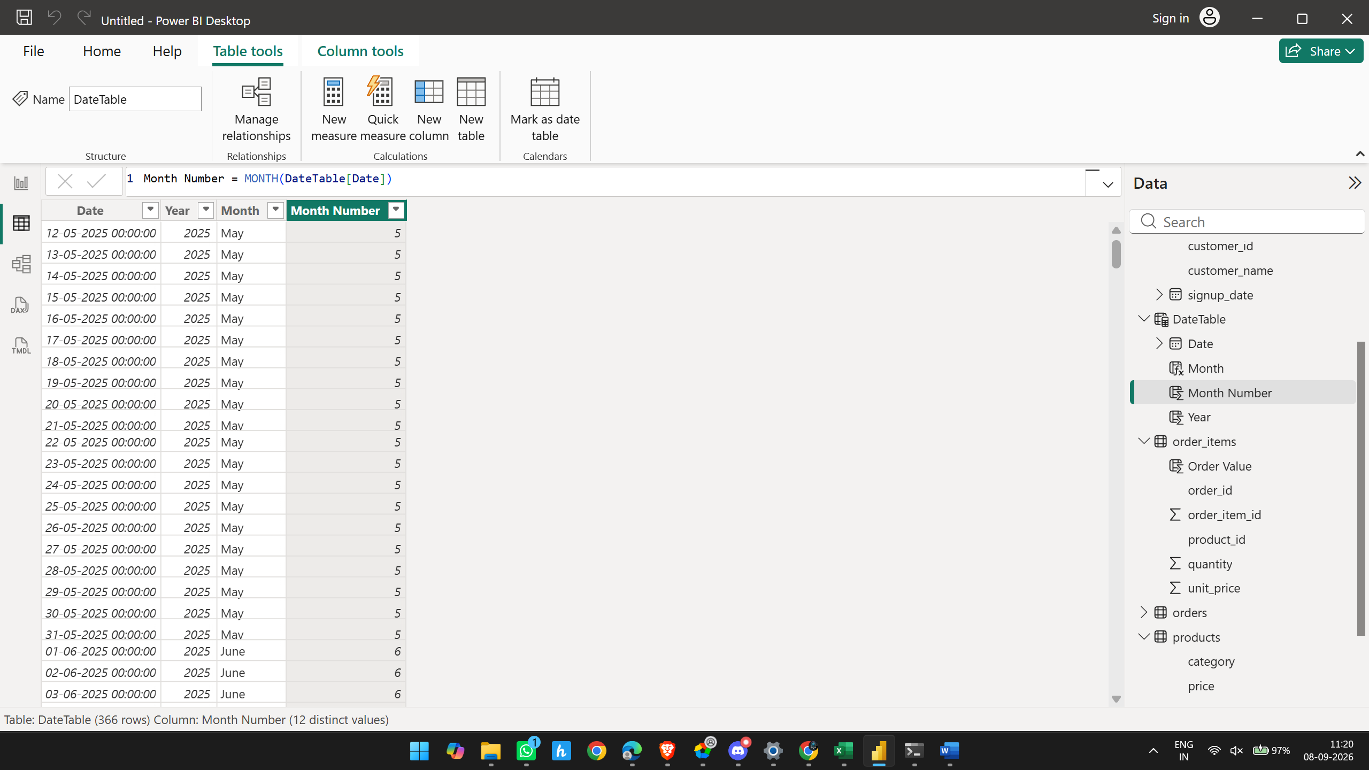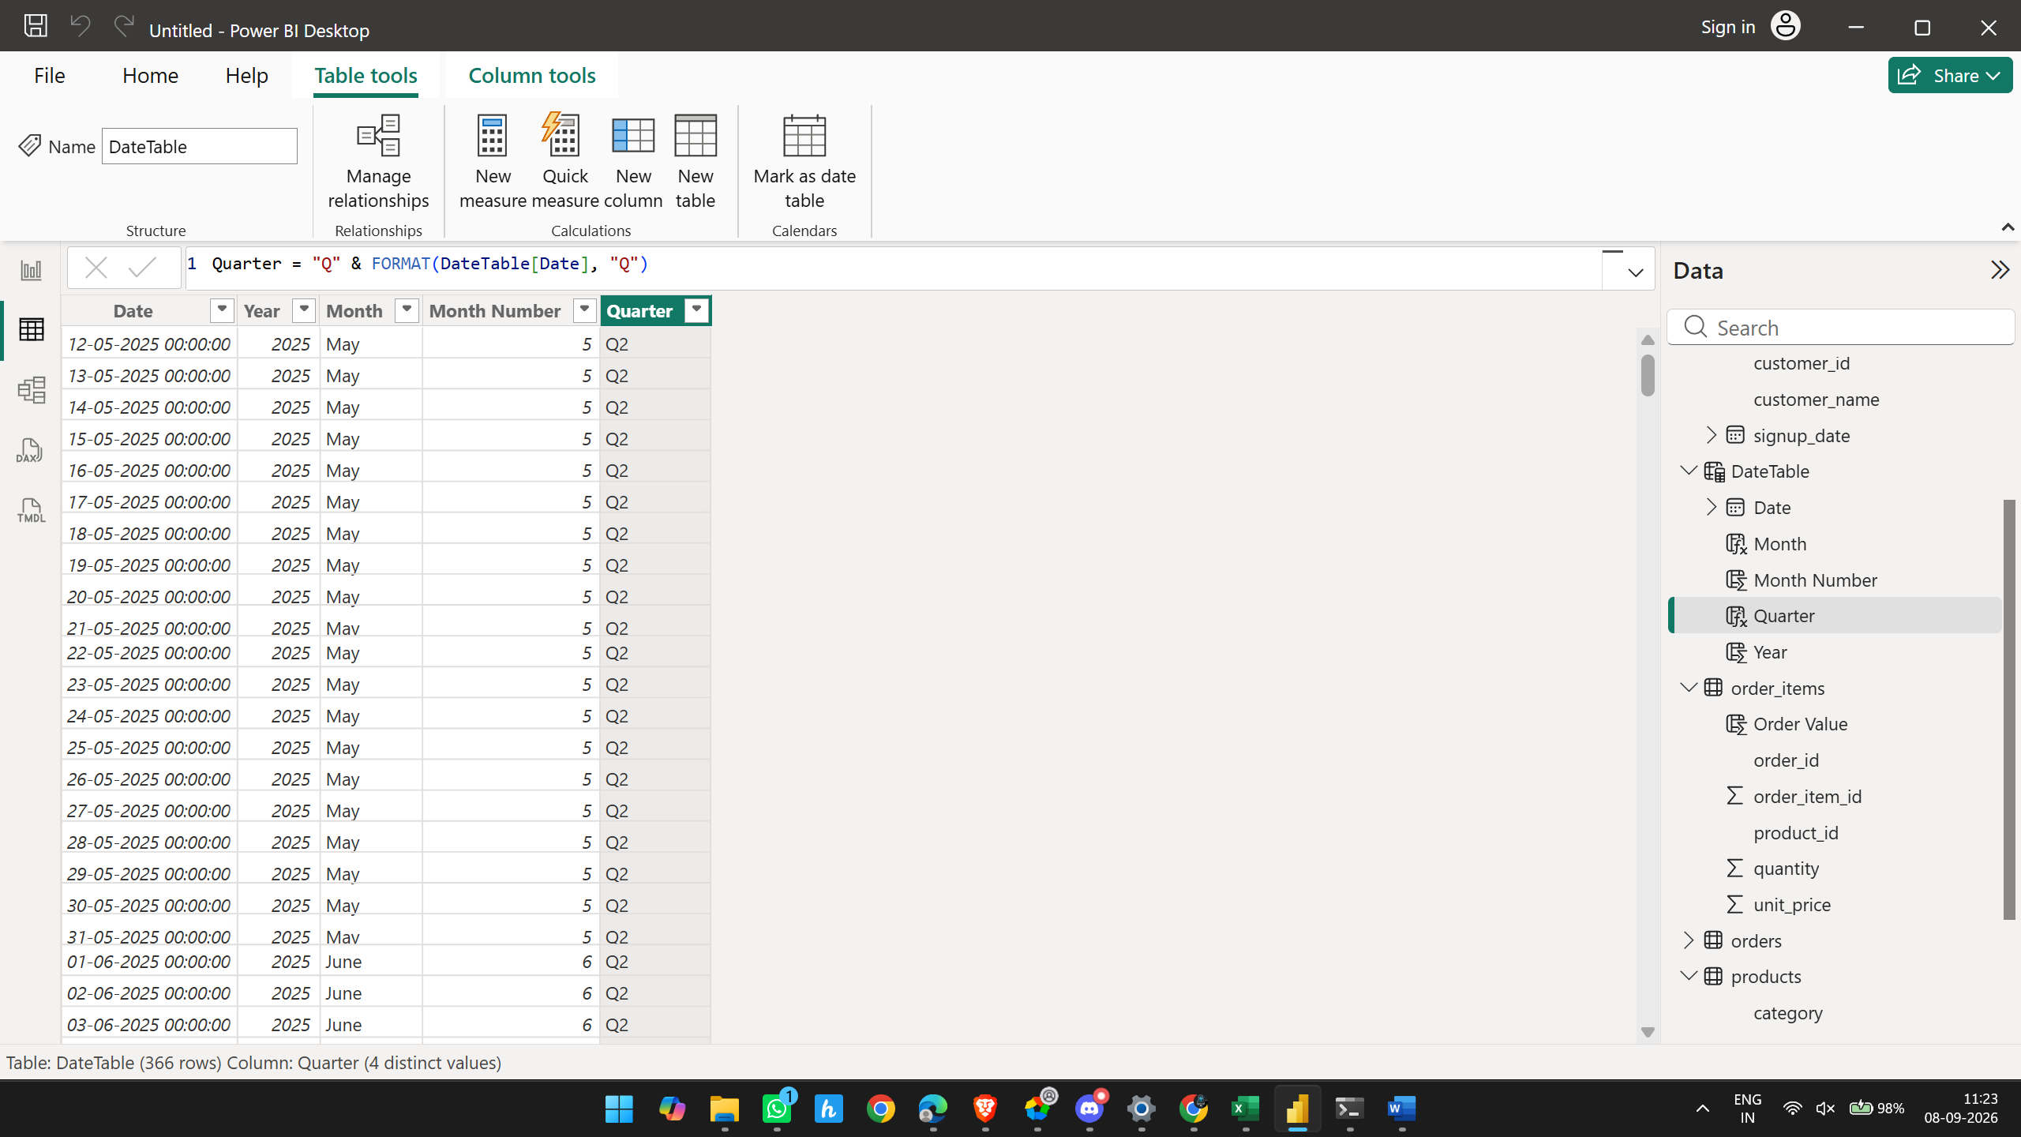

Now model view connecting datetable to orders table
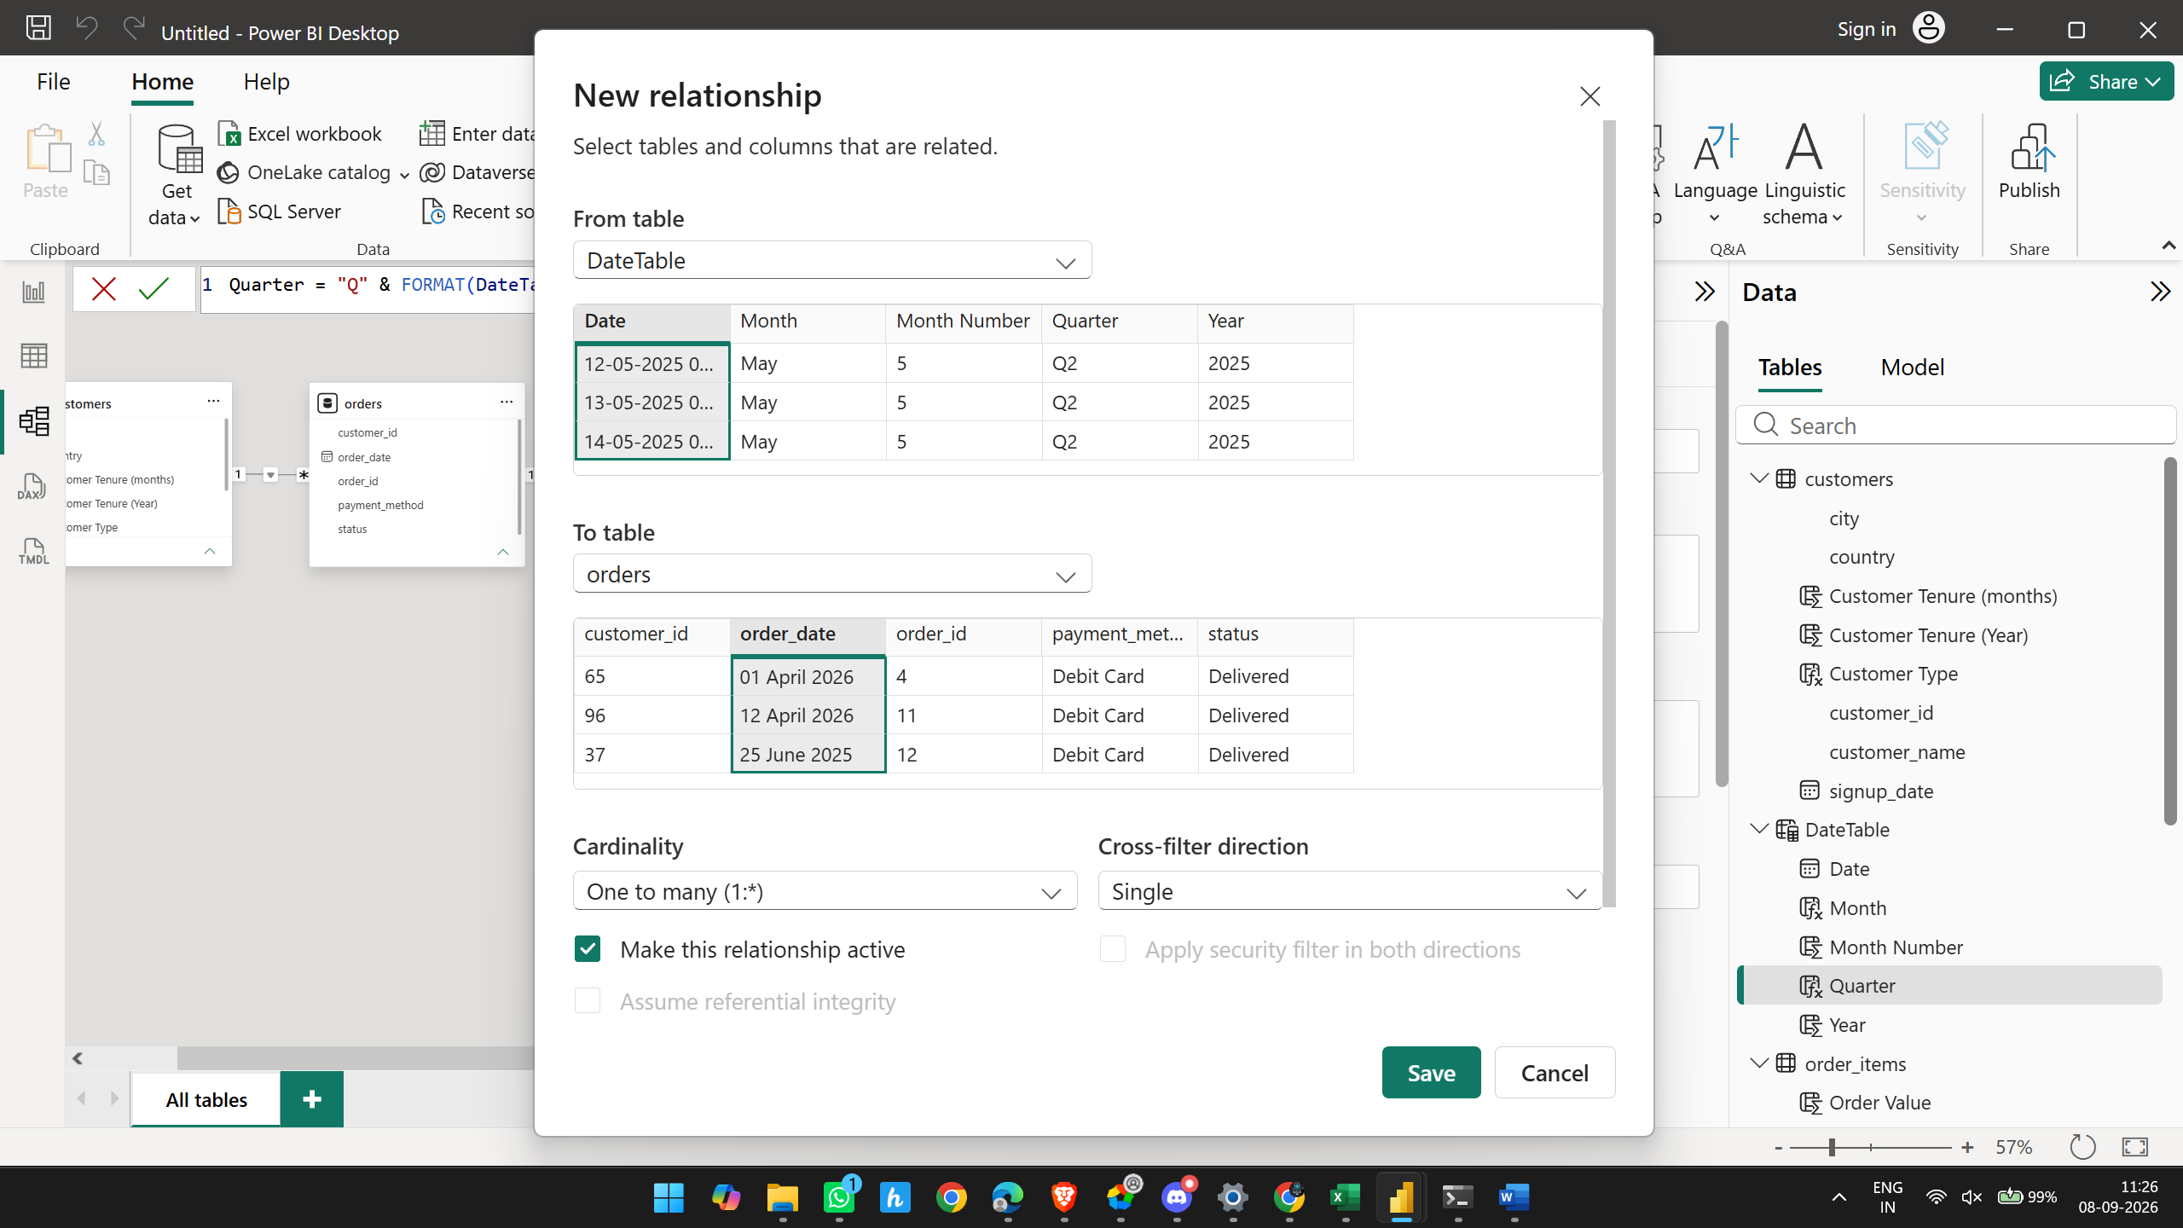
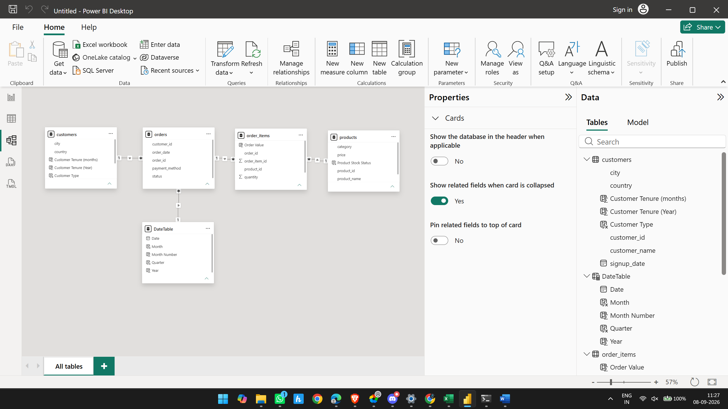

2.4 Business Columns — COMPLETE
You've created:
- ✅ Order Value
- ✅ Customer Tenure (months)
- ✅ Customer Tenure (year)
- ✅ Product Stock Status
- ✅ Customer Type
And you've created the DateTable needed for time analysis.
So Sprint 2 is essentially complete.

Sprint 3: KPI Identification & DAX Measures

Objective
Identify the key business KPIs required to measure Sales, Customers, Products, and Orders, and create the corresponding DAX measures in Power BI.
3.1 Sales KPIs
KPI | What it measures
Total Revenue | Total sales generated
Total Orders | Total number of orders
Average Order Value (AOV) | Average revenue generated per order
Total Quantity Sold | Total units/products sold
Revenue Growth % | Change in revenue compared with the previous period

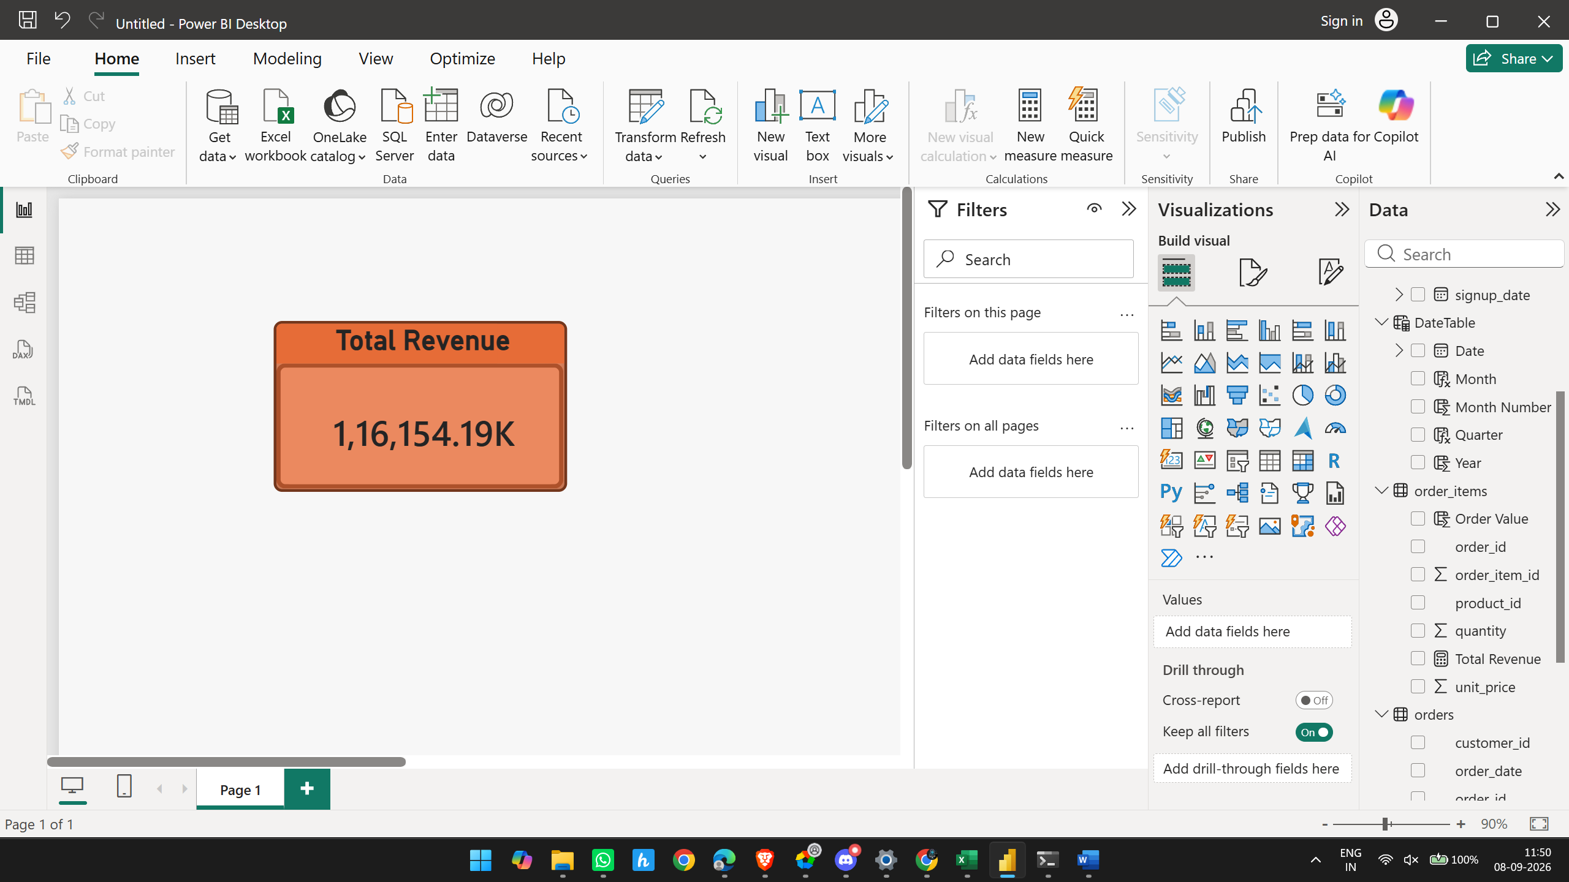
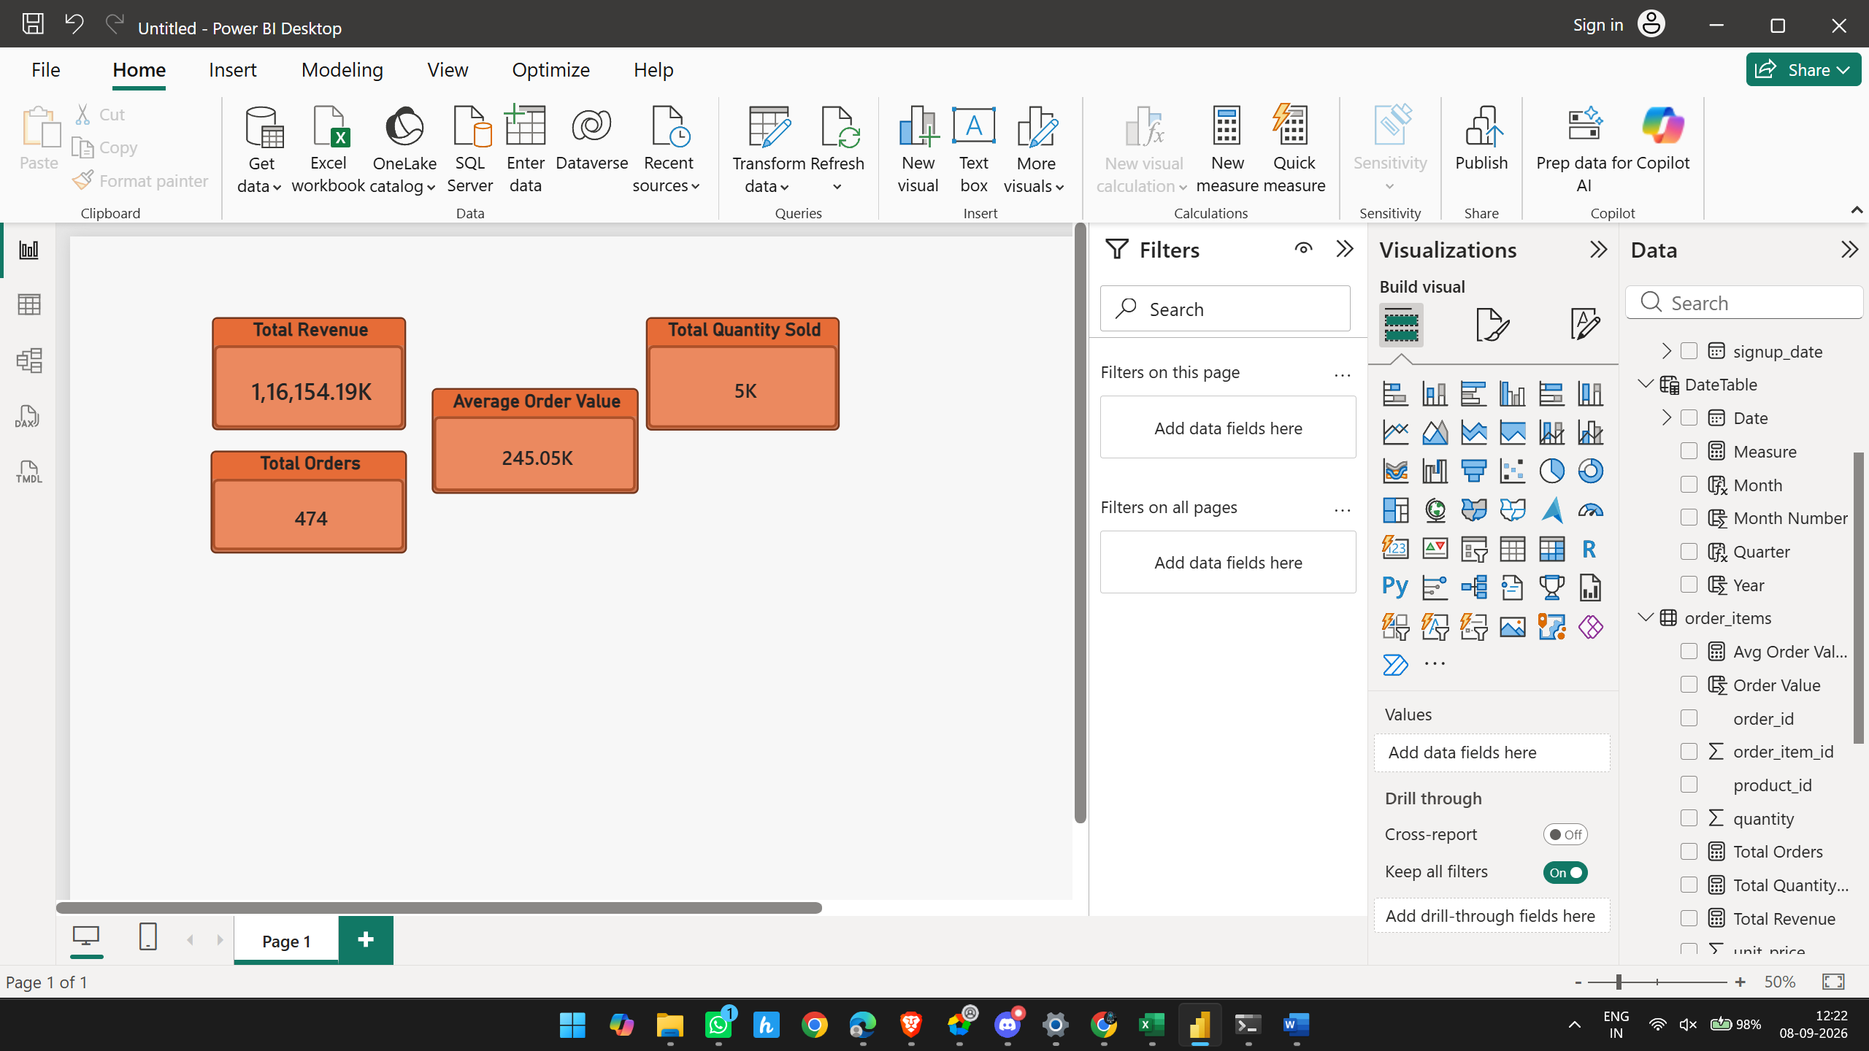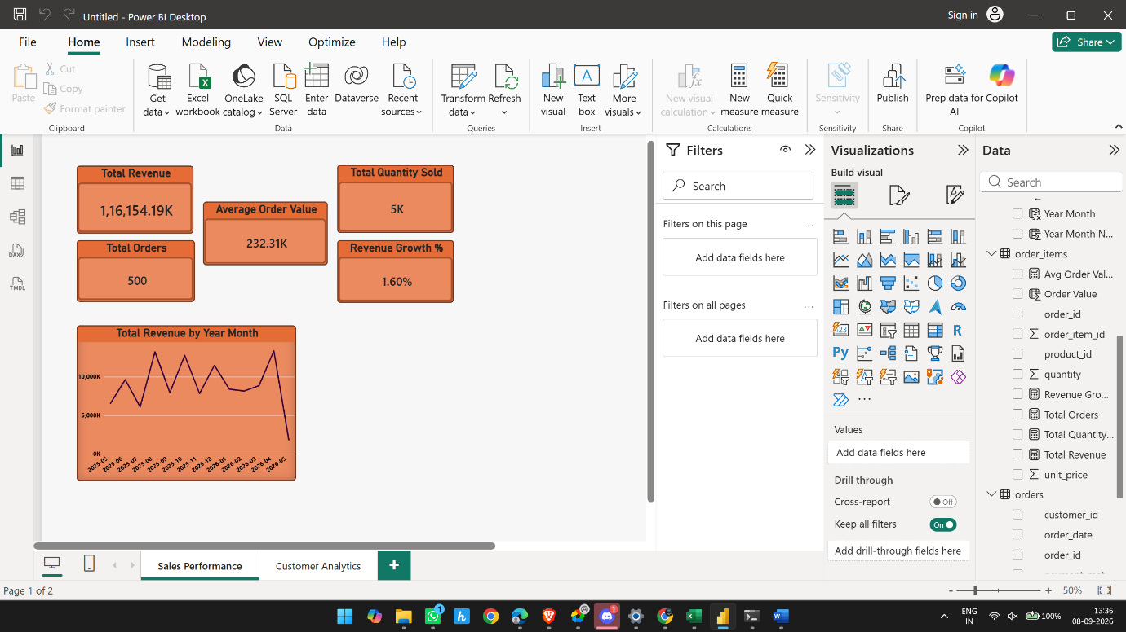

KPI / Visual | Result
Total Revenue | ₹116,154.19K
Total Orders | 500 ✅
AOV | ₹232.31K ✅
Total Quantity Sold | 5K
Revenue Growth % | 1.60%
Monthly Revenue Trend | ✅

Customer analytics
1.

2.
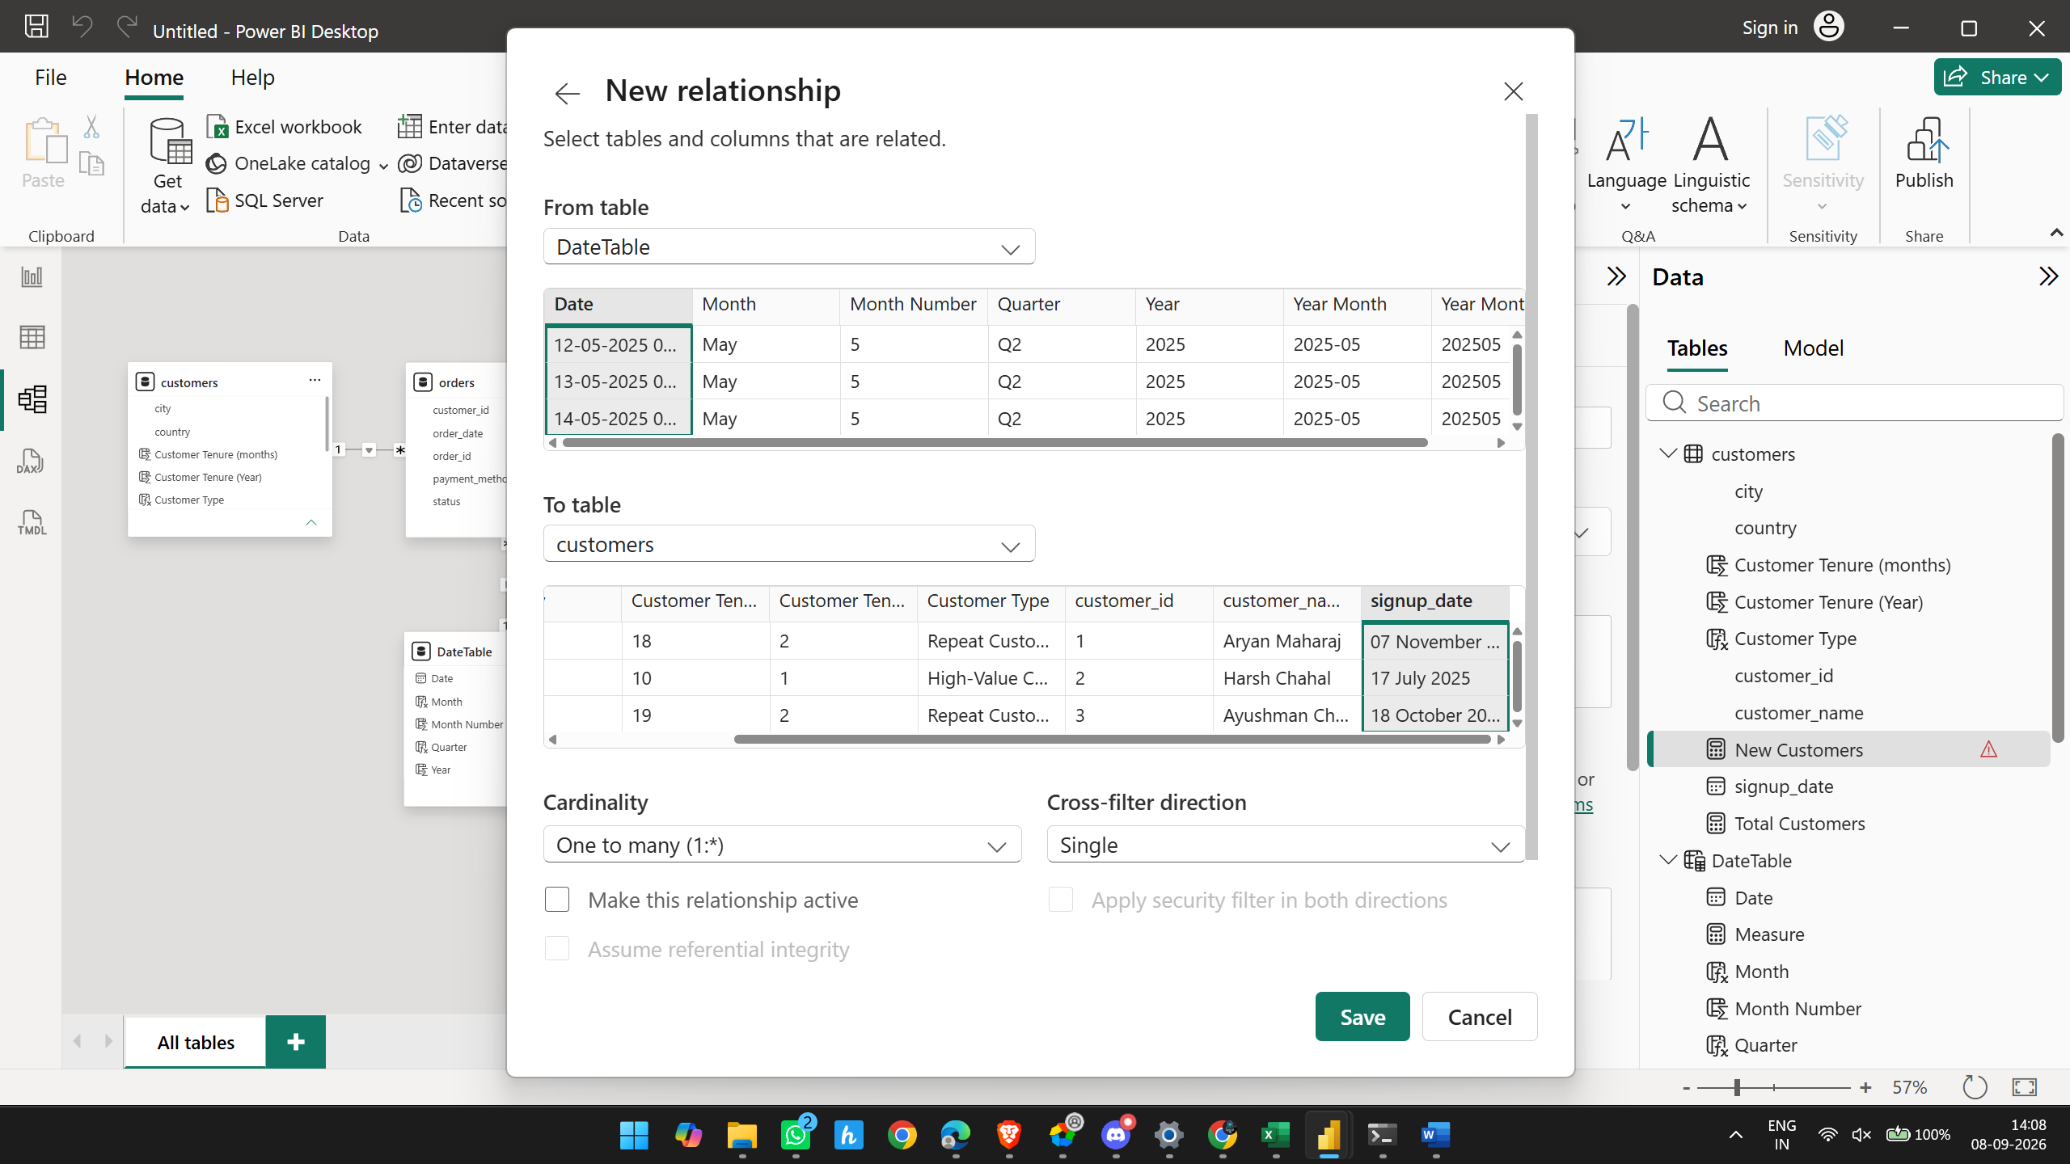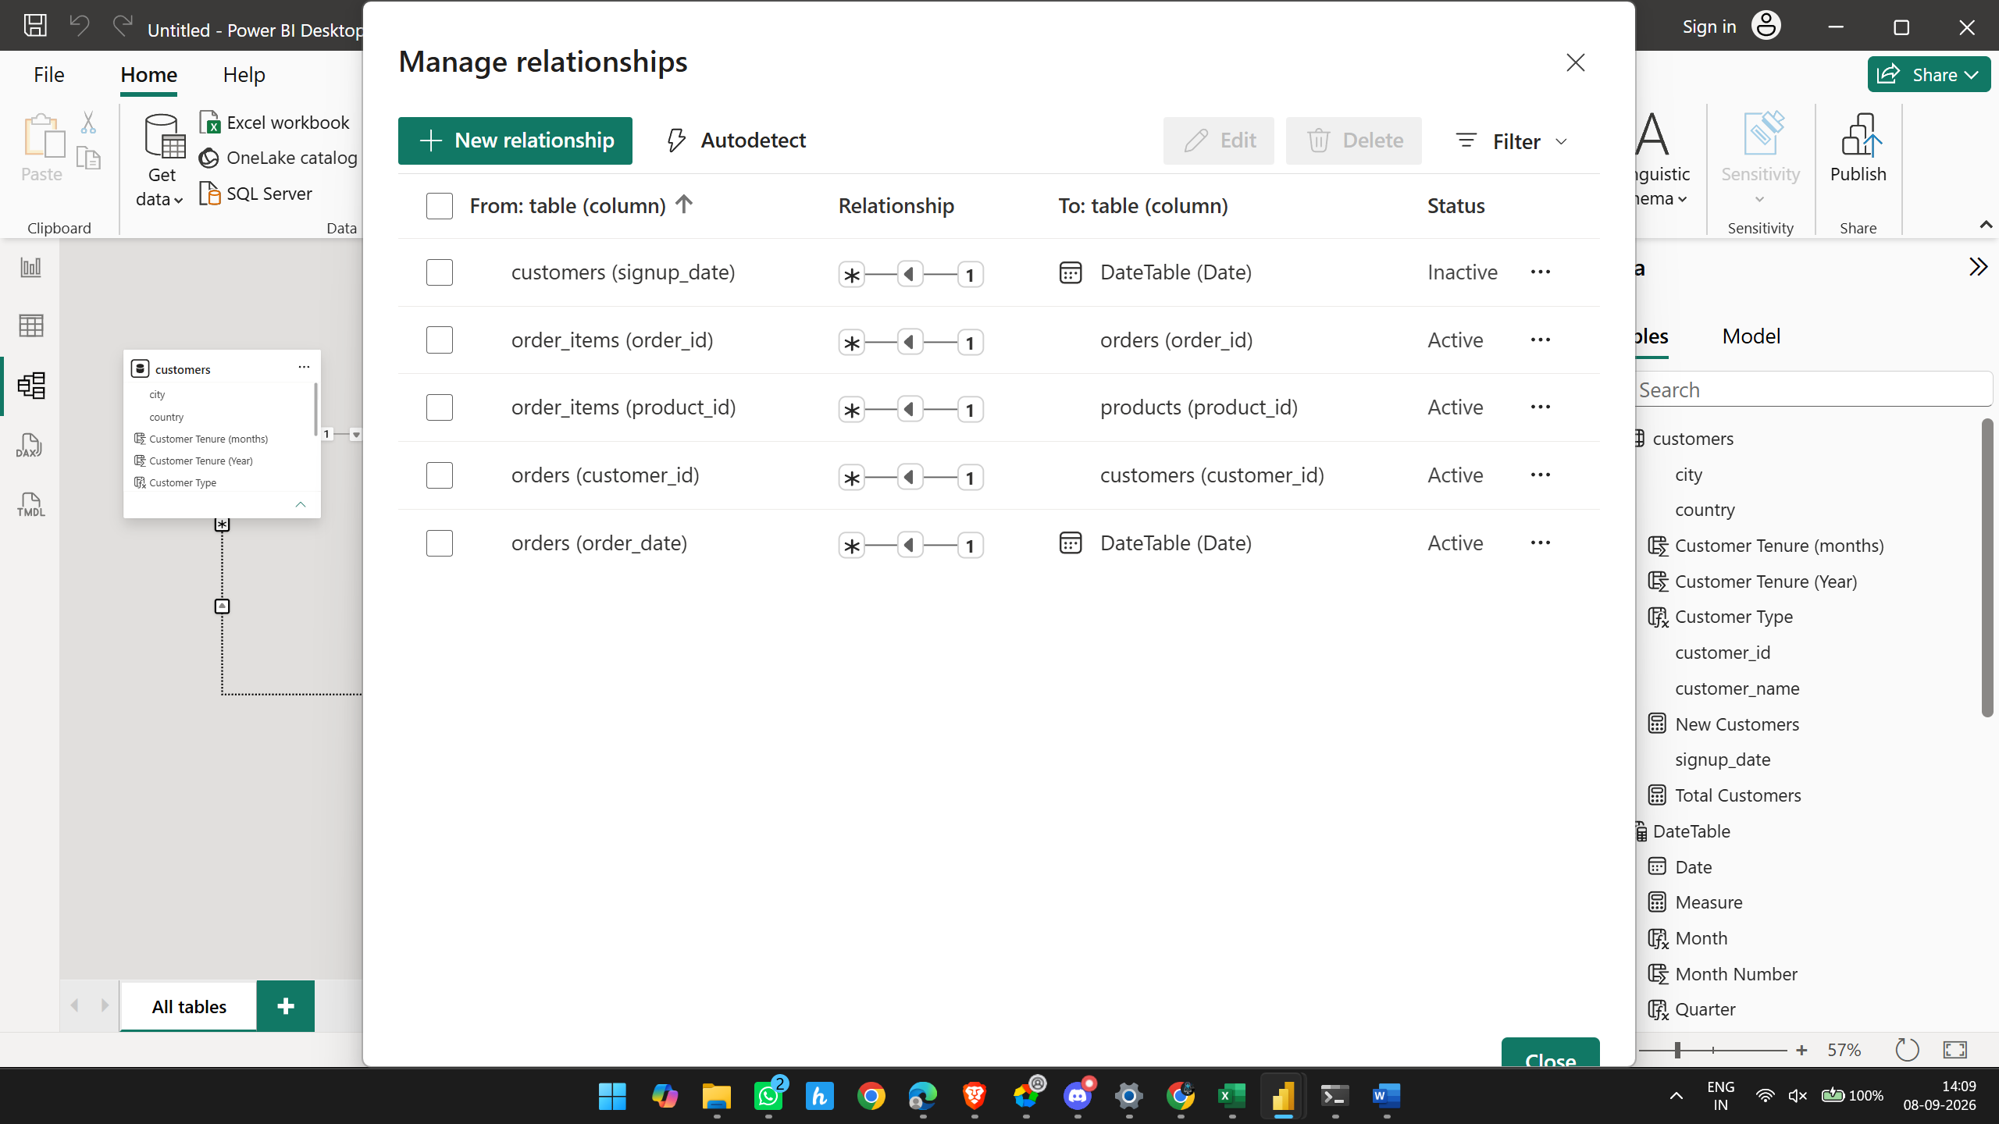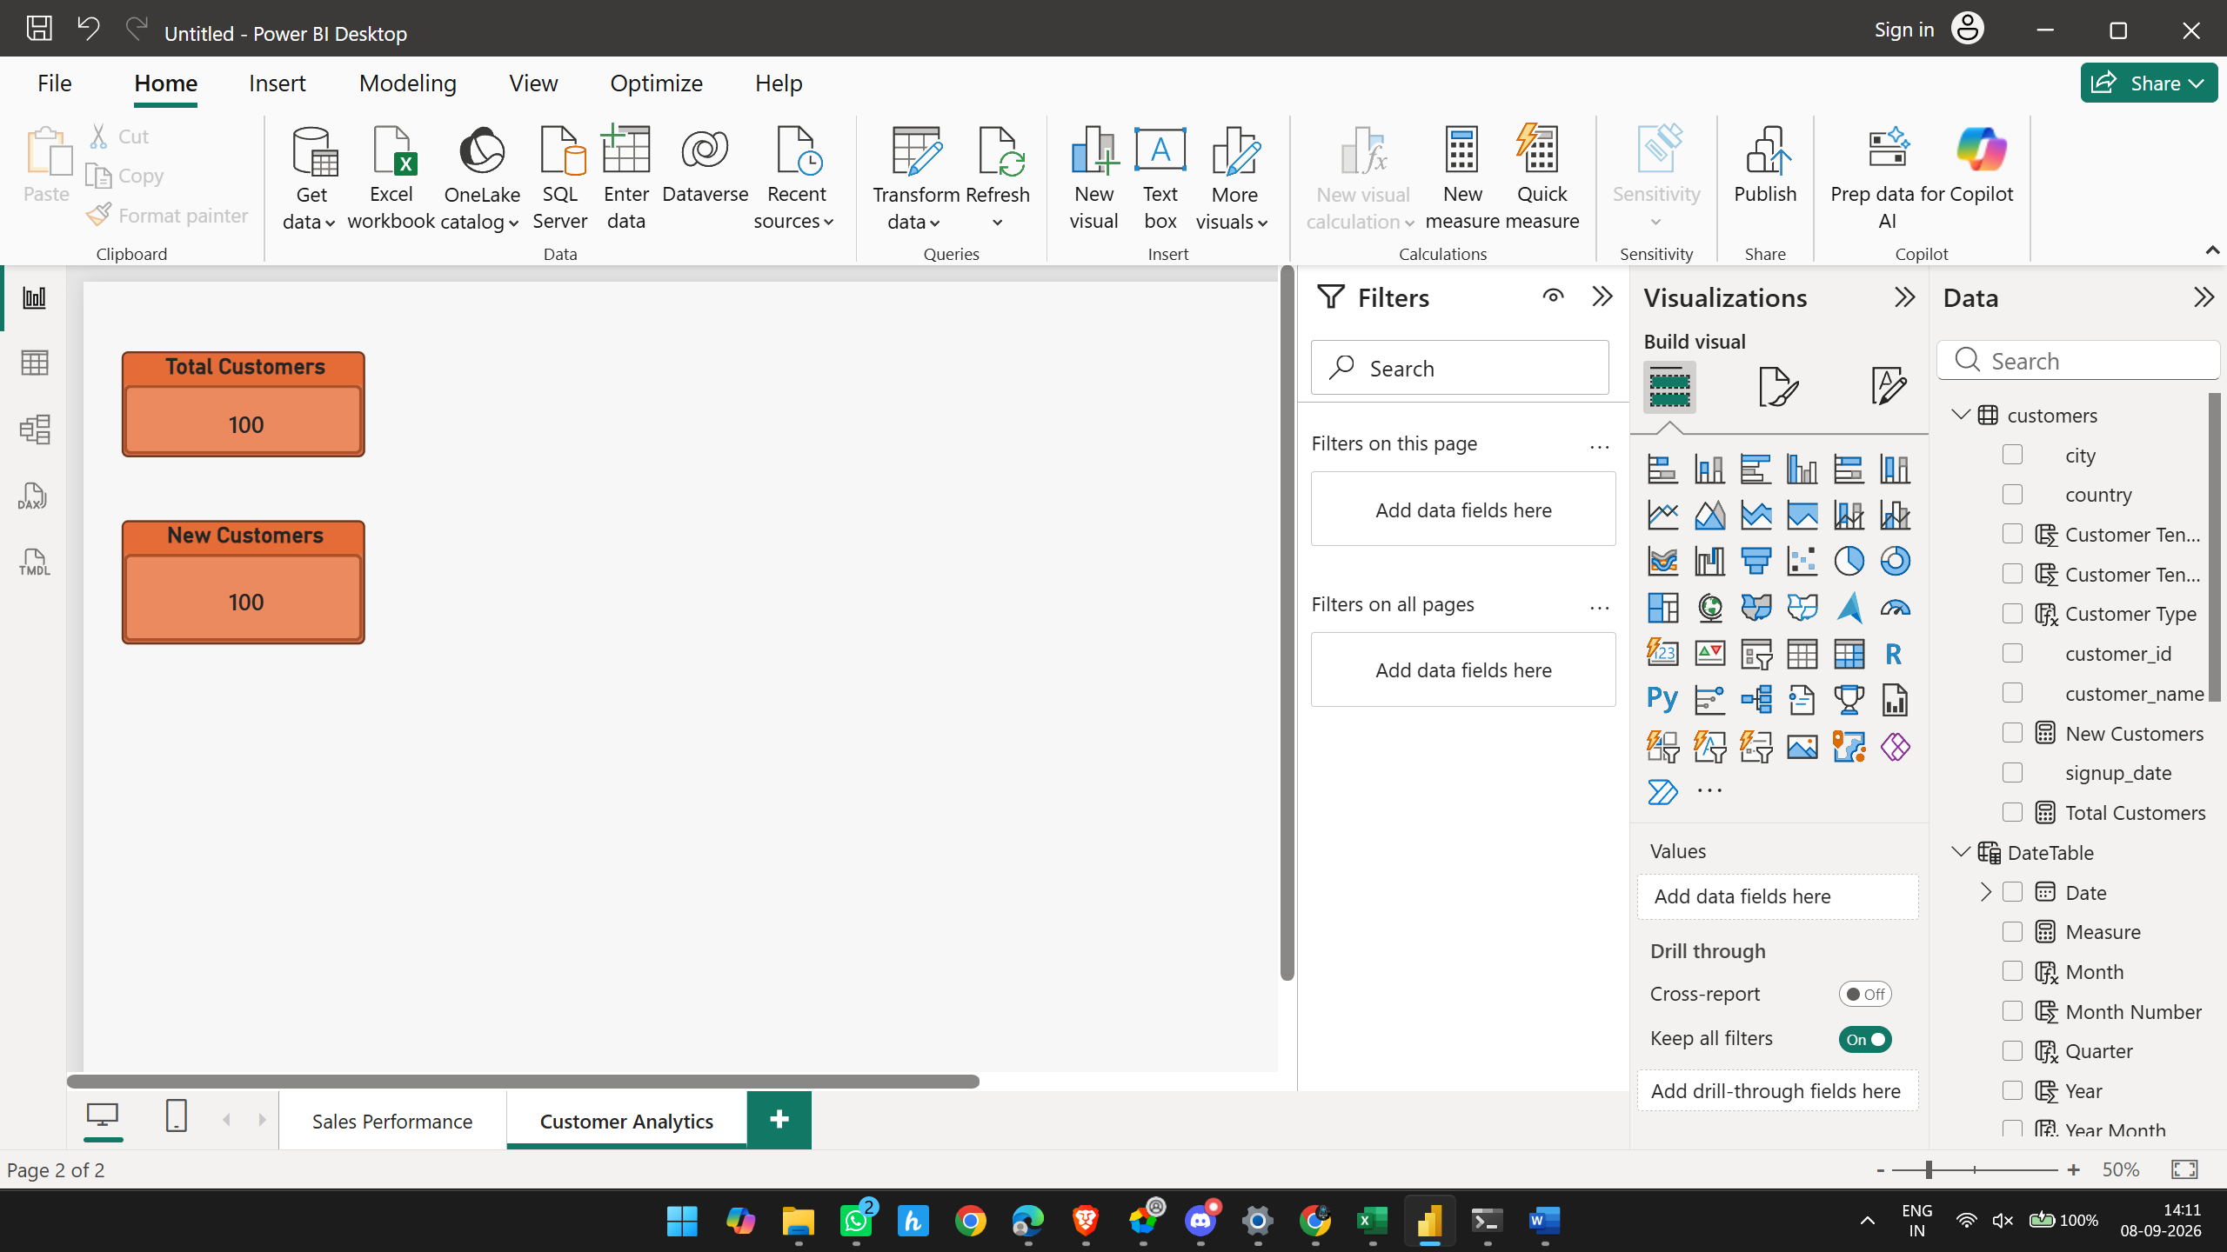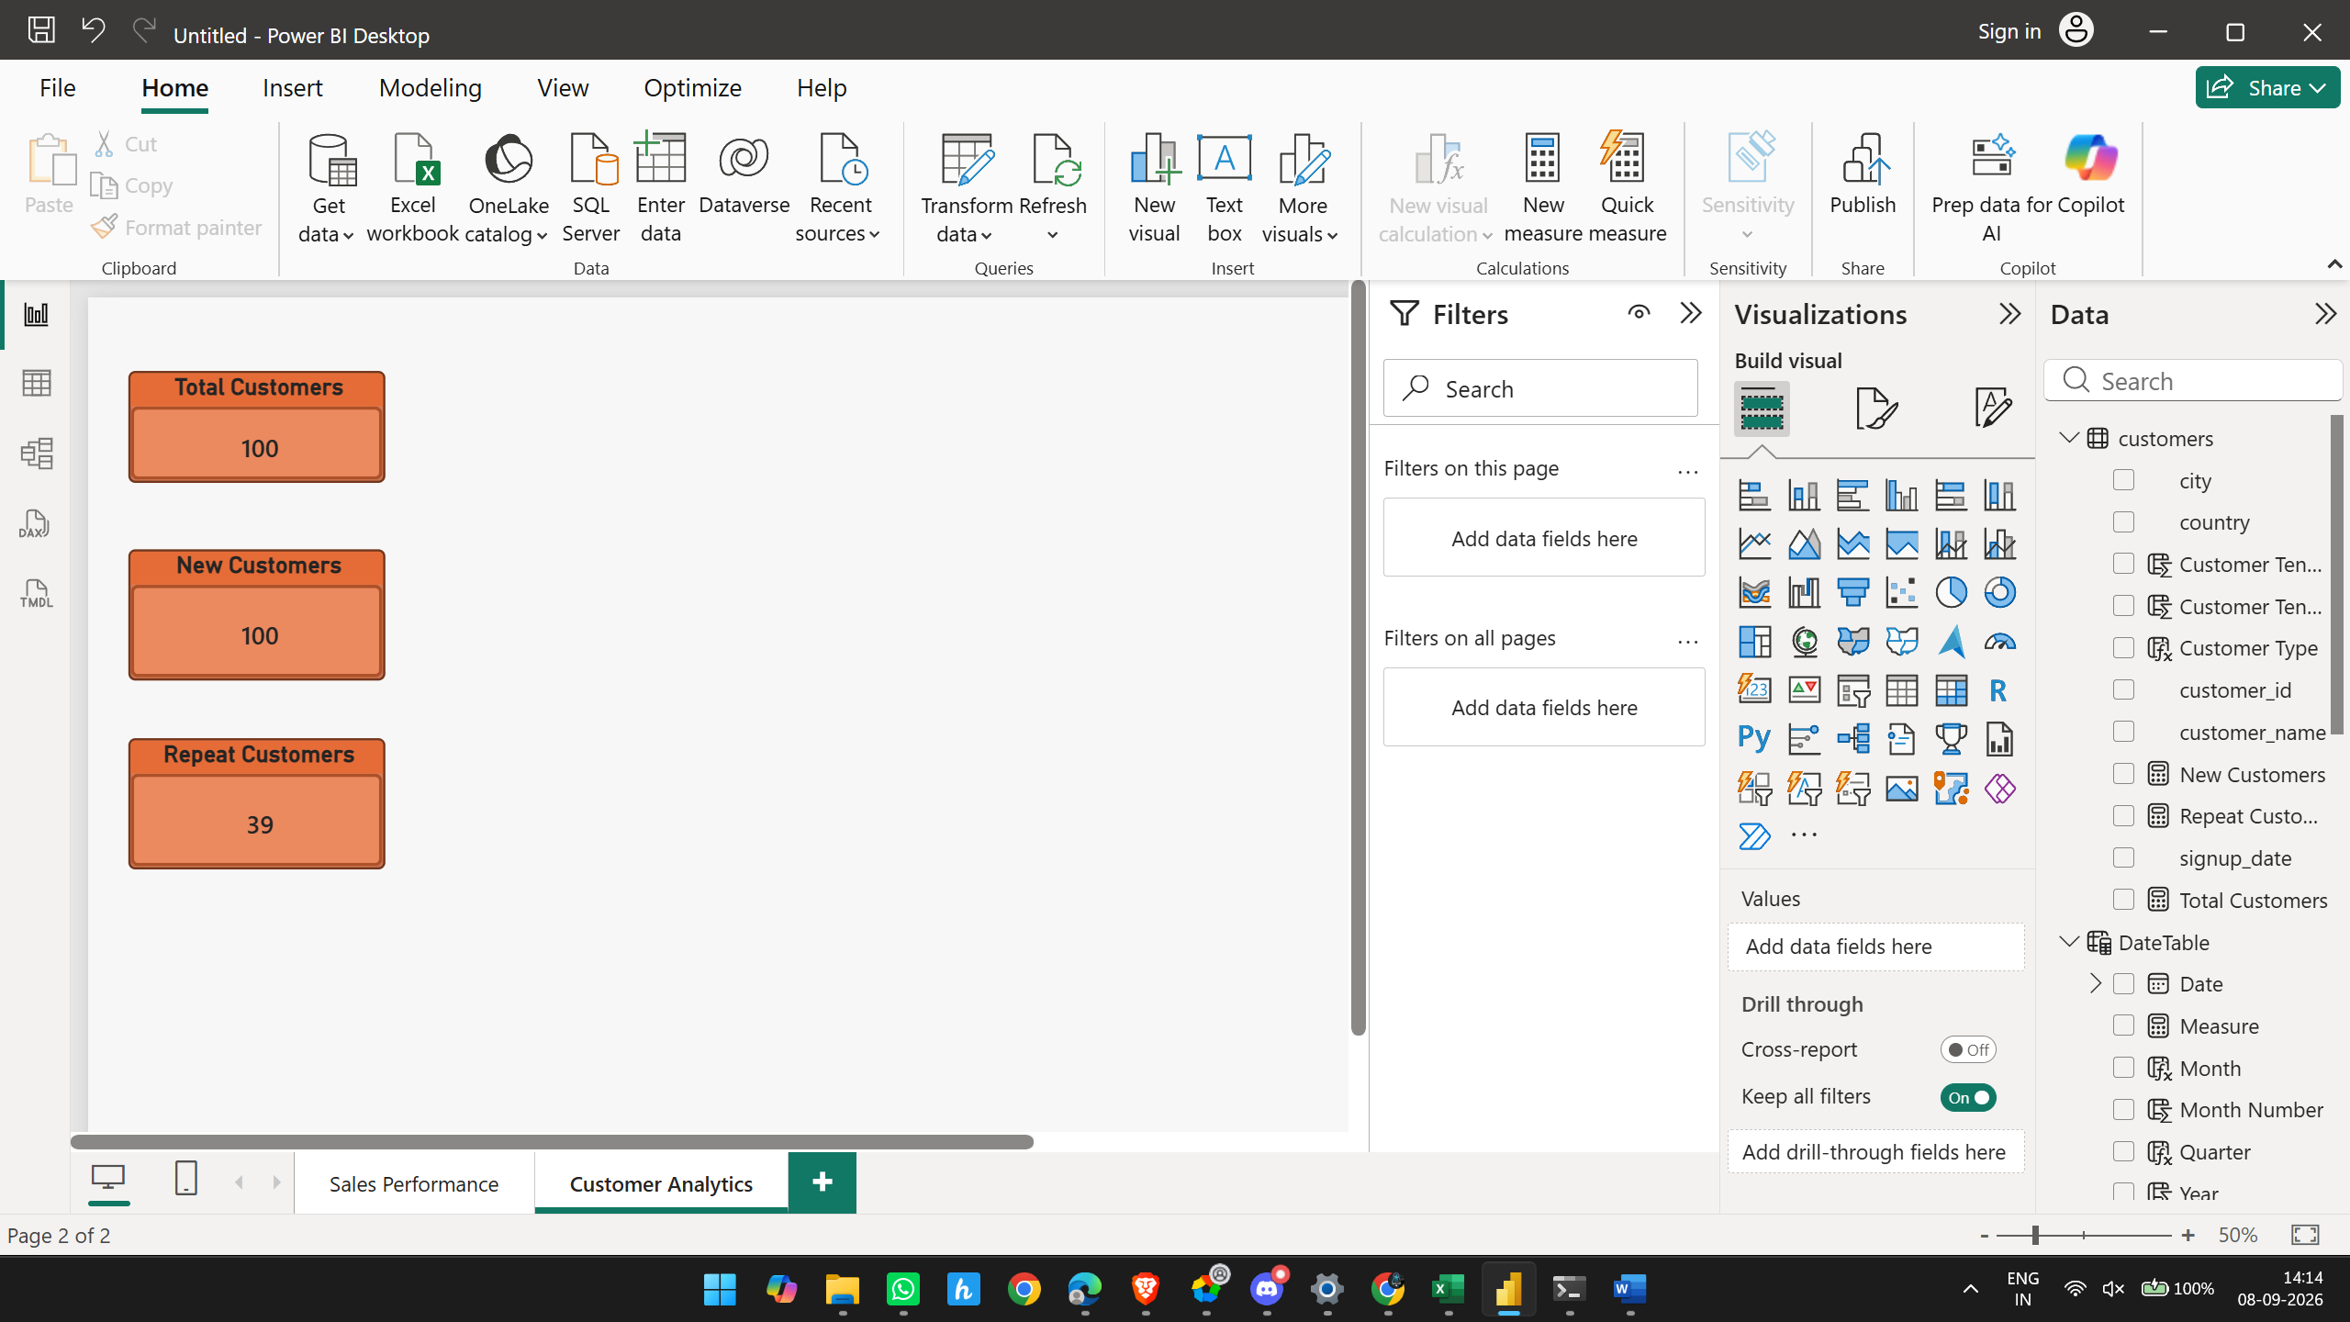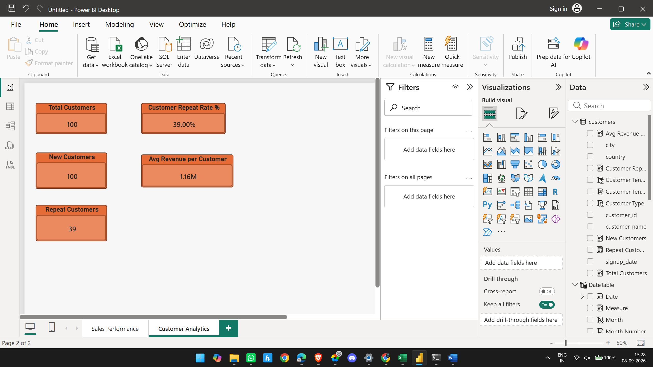

Dashboard 1 — Sales Performance ✅
We completed:
- ✅ Total Revenue
- ✅ Total Orders
- ✅ AOV
- ✅ Total Quantity Sold
- ✅ Revenue Growth %
- ✅ Revenue trend
- ✅ Revenue by Category
- ✅ Top 10 Products
- ✅ Revenue by City
- ✅ Date filter
- ✅ Year filter
- ✅ Category filter
- ✅ City filter
- ✅ Order Status filter
- ✅ Business insights
- ✅ Recommendations
Status: COMPLETE ✅

Dashboard 2 — Customer Analytics ✅
We completed:
- ✅ Total Customers
- ✅ New Customers
- ✅ Repeat Customers
- ✅ Repeat Rate %
- ✅ Avg Revenue per Customer
- ✅ Customer Revenue / customer value analysis
- ✅ Customer Segmentation
- ✅ Customer Distribution by City
- ✅ Top 10 Customers by Revenue
- ✅ Customer Signup Trend
- ✅ Customer Name filter
- ✅ City filter
- ✅ Customer Type filter
Status: COMPLETE ✅

Dashboard 3 checklist
Assignment requirement | Status
Revenue by Category | ✅
Quantity Sold | ✅
Top Products | ✅
Bottom Products | ✅
Product Stock | ✅
Average Selling Price | ✅
Category Contribution | ✅
Products needing attention | ✅
Stock-status conditional formatting | ✅
Revenue data bars | ✅
Category filter | ✅
Stock Status filter | ✅
Product filter | ✅

Dashboard 4 — Final Check
Requirement | Status
Total Orders | ✅ 500
Delivered Orders | ✅ 349
Cancelled Orders | ✅ 53
Cancellation Rate | ✅ 10.60%
Delivery Rate | ✅ 69.80%
Orders by Payment Method | ✅
Revenue by Payment Method | ✅
Order Trend | ✅
Cancellation Patterns | ✅
Cancellation by City | ✅
Order Status distribution | ✅
Date filter | ✅
Payment Method filter | ✅
Order Status filter | ✅
City filter | ✅

Data Modeling:
